






Perform child protection duties relevant to the tourism industry
D1.HRS.CL1.20
D1.HOT.CL1.13
D2.TCC.CL1.14
Trainer Guide

Perform child protection duties relevant to the tourism industry

D1.HRS.CL1.20
D1.HOT.CL1.13
D2.TCC.CL1.14

Trainer Guide





Project Base
William Angliss Institute of TAFE
555 La Trobe Street
Melbourne 3000 Victoria
Telephone: | (03) 9606 2111
Facsimile: | (03) 9670 1330
Acknowledgements
Project Director: | Wayne Crosbie
Chief Writer: | Alan Hickman
Subject Writer: | Rob Steer
Project Manager/Editor: | Alan Maguire
DTP/Production | Daniel Chee, Mai Vu, Jirayu Thangcharoensamut, Kaly Quach

The Association of Southeast Asian Nations (ASEAN) was established on 8 August 1967. The Member States of the Association are Brunei Darussalam, Cambodia, Indonesia, Lao PDR, Malaysia, Myanmar, Philippines, Singapore, Thailand and Viet Nam.
The ASEAN Secretariat is based in Jakarta, Indonesia.
General Information on ASEAN appears online at the ASEAN Website: www.asean.org.
All text is produced by William Angliss Institute of TAFE for the ASEAN Project on “Toolbox Development for Priority Tourism Labour Division”.
This publication is supported by the Australian Government’s aid program through the ASEAN-Australia Development Cooperation Program Phase II (AADCP II).
Copyright: Association of Southeast Asian Nations (ASEAN) 2012.
All rights reserved.
Disclaimer
Every effort has been made to ensure that this publication is free from errors or omissions. However, you should conduct your own enquiries and seek professional advice before relying on any fact, statement or matter contained in this book. The ASEAN Secretariat and William Angliss Institute of TAFE are not responsible for any injury, loss or damage as a result of material included or omitted from this course. Information in this module is current at the time of publication. Time of publication is indicated in the date stamp at the bottom of each page.
Some images appearing in this resource have been purchased from stock photography suppliers Shutterstock and iStockphoto and other third party copyright owners and as such are non-transferable and non-exclusive. Clip arts, font images and illustrations used are from the Microsoft Office Clip Art and Media Library. Some images have been provided by and are the property of William Angliss Institute.
Additional images have been sourced from Flickr and SXC and are used under Creative Commons licence: http://creativecommons.org/licenses/by/2.0/deed.en

File name: TG_Perform_child_protection_duties_refined.docx





Table of contents
Competency Based Training (CBT) and assessment an introduction for trainers 1
Competency standard 11
Notes and PowerPoint slides 19
Recommended training equipment 89
Instructions for Trainers for using PowerPoint – Presenter View 91
Appendix – ASEAN acronyms 93

Competency Based Training (CBT) and assessment an introduction for trainers

Competency
Competency refers to the ability to perform particular tasks and duties to the standard of performance expected in the workplace.
Competency requires the application of specified knowledge, skills and attitudes relevant to effective participation, consistently over time and in the workplace environment.
The essential skills and knowledge are either identified separately or combined.
Knowledge identifies what a person needs to know to perform the work in an informed and effective manner.
Skills describe the application of knowledge to situations where understanding is converted into a workplace outcome.
Attitude describes the founding reasons behind the need for certain knowledge or why skills are performed in a specified manner.
Competency covers all aspects of workplace performance and involves:
- Performing individual tasks
- Managing a range of different tasks
- Responding to contingencies or breakdowns
- Dealing with the responsibilities of the workplace
- Working with others.

Unit of Competency
Like with any training qualification or program, a range of subject topics are identified that focus on the ability in a certain work area, responsibility or function.
Each manual focuses on a specific unit of competency that applies in the hospitality workplace.
In this manual a unit of competency is identified as a ‘unit’.
Each unit of competency identifies a discrete workplace requirement and includes:
- Knowledge and skills that underpin competency
- Language, literacy and numeracy
- Occupational safety and health requirements.
Each unit of competency must be adhered to in training and assessment to ensure consistency of outcomes.

Element of Competency
An element of competency describes the essential outcomes within a unit of competency.
The elements of competency are the basic building blocks of the unit of competency. They describe in terms of outcomes the significant functions and tasks that make up the competency.
In this manual elements of competency are identified as an ‘element’.

Performance criteria
Performance criteria indicate the standard of performance that is required to demonstrate achievement within an element of competency. The standards reflect identified industry skill needs.
Performance criteria will be made up of certain specified skills, knowledge and attitudes.

Learning
For the purpose of this manual learning incorporates two key activities:
- Training
- Assessment.
Both of these activities will be discussed in detail in this introduction.
Today training and assessment can be delivered in a variety of ways. It may be provided to participants:
- On-the-job – in the workplace
- Off-the-job – at an educational institution or dedicated training environment
- As a combination of these two options.
No longer is it necessary for learners to be absent from the workplace for long periods of time in order to obtain recognised and accredited qualifications.

Learning Approaches
This manual will identify two avenues to facilitate learning:
Competency Based Training (CBT)
This is the strategy of developing a participant’s competency.
Educational institutions utilise a range of training strategies to ensure that participants are able to gain the knowledge and skills required for successful:
- Completion of the training program or qualification
- Implementation in the workplace.
The strategies selected should be chosen based on suitability and the learning styles of participants.

Competency Based Assessment (CBA)
This is the strategy of assessing competency of a participant.
Educational institutions utilise a range of assessment strategies to ensure that participants are assessed in a manner that demonstrates validity, fairness, reliability, flexibility and fairness of assessment processes.

Flexibility in Learning
It is important to note that flexibility in training and assessment strategies is required to meet the needs of participants who may have learning difficulties. The strategies used will vary, taking into account the needs of individual participants with learning difficulties. However they will be applied in a manner which does not discriminate against the participant or the participant body as a whole.
Catering for Participant Diversity
Participants have diverse backgrounds, needs and interests. When planning training and assessment activities to cater for individual differences, trainers and assessors should:
- Consider individuals’ experiences, learning styles and interests
- Develop questions and activities that are aimed at different levels of ability
- Modify the expectations for some participants
- Provide opportunities for a variety of forms of participation, such as individual, pair and small group activities
- Assess participants based on individual progress and outcomes.
The diversity among participants also provides a good reason for building up a learning community in which participants support each other’s learning.
Participant Centred Learning
This involves taking into account structuring training and assessment that:
- Builds on strengths – Training environments need to demonstrate the many positive features of local participants (such as the attribution of academic success to effort, and the social nature of achievement motivation) and of their trainers (such as a strong emphasis on subject disciplines and moral responsibility). These strengths and uniqueness of local participants and trainers should be acknowledged and treasured
- Acknowledges prior knowledge and experience – The learning activities should be planned with participants’ prior knowledge and experience in mind
- Understands learning objectives – Each learning activity should have clear learning objectives and participants should be informed of them at the outset. Trainers should also be clear about the purpose of assignments and explain their significance to participants
- Teaches for understanding – The pedagogies chosen should aim at enabling participants to act and think flexibly with what they know
- Teaches for independent learning – Generic skills and reflection should be nurtured through learning activities in appropriate contexts of the curriculum. Participants should be encouraged to take responsibility for their own learning
- Enhances motivation – Learning is most effective when participants are motivated. Various strategies should be used to arouse the interest of participants
- Makes effective use of resources – A variety of teaching resources can be employed as tools for learning
- Maximises engagement – In conducting learning activities, it is important for the minds of participants to be actively engaged
- Aligns assessment with learning and teaching – Feedback and assessment should be an integral part of learning and teaching
- Caters for learner diversity – Trainers should be aware that participants have different characteristics and strengths and try to nurture these rather than impose a standard set of expectations.
Active Learning
The goal of nurturing independent learning in participants does not imply that they always have to work in isolation or solely in a classroom. On the contrary, the construction of knowledge in tourism and hospitality studies can often best be carried out in collaboration with others in the field. Sharing experiences, insights and views on issues of common concern, and working together to collect information through conducting investigative studies in the field (active learning) can contribute a lot to their eventual success.
Active learning has an important part to play in fostering a sense of community in the class. First, to operate successfully, a learning community requires an ethos of acceptance and a sense of trust among participants, and between them and their trainers. Trainers can help to foster acceptance and trust through encouragement and personal example, and by allowing participants to take risks as they explore and articulate their views, however immature these may appear to be. Participants also come to realise that their classmates (and their trainers) are partners in learning and solving.
Trainers can also encourage cooperative learning by designing appropriate group learning tasks, which include, for example, collecting background information, conducting small-scale surveys, or producing media presentations on certain issues and themes. Participants need to be reminded that, while they should work towards successful completion of the field tasks, developing positive peer relationships in the process is an important objective of all group work.

Competency Based Training (CBT)
Principle of Competency Based Training
Competency based training is aimed at developing the knowledge, skills and attitudes of participants, through a variety of training tools.
Training Strategies
The aims of this curriculum are to enable participants to:
- Undertake a variety of subject courses that are relevant to industry in the current environment
- Learn current industry skills, information and trends relevant to industry
- Learn through a range of practical and theoretical approaches
- Be able to identify, explore and solve issues in a productive manner
- Be able to become confident, equipped and flexible managers of the future
- Be ‘job ready’ and a valuable employee in the industry upon graduation of any qualification level.
To ensure participants are able to gain the knowledge and skills required to meet competency in each unit of competency in the qualification, a range of training delivery modes are used.
Types of Training
In choosing learning and teaching strategies, trainers should take into account the practical, complex and multi-disciplinary nature of the subject area, as well as their participant’s prior knowledge, learning styles and abilities.
Training outcomes can be attained by utilising one or more delivery methods:
Lecture/Tutorial
This is a common method of training involving transfer of information from the trainer to the participants. It is an effective approach to introduce new concepts or information to the learners and also to build upon the existing knowledge. The listener is expected to reflect on the subject and seek clarifications on the doubts.
Demonstration
Demonstration is a very effective training method that involves a trainer showing a participant how to perform a task or activity. Through a visual demonstration, trainers may also explain reasoning behind certain actions or provide supplementary information to help facilitate understanding.
Group Discussions
Brainstorming in which all the members in a group express their ideas, views and opinions on a given topic, is a free flow and exchange of knowledge among the participants and the trainer. The discussion is carried out by the group on the basis of their own experience, perceptions and values. This will facilitate acquiring new knowledge. When everybody is expected to participate in the group discussion, even the introverted persons will also get stimulated and try to articulate their feelings.
The ideas that emerge in the discussions should be noted down and presentations are to be made by the groups. Sometimes consensus needs to be arrived at on a given topic. Group discussions are to be held under the moderation of a leader guided by the trainer. Group discussion technique triggers thinking process, encourages interactions and enhances communication skills.
Role Play
This is a common and very effective method of bringing into the classroom real life situations, which may not otherwise be possible. Participants are made to enact a particular role so as to give a real feel of the roles they may be called upon to play. This enables participants to understand the behaviour of others as well as their own emotions and feelings. The instructor must brief the role players on what is expected of them. The role player may either be given a ready-made script, which they can memorise and enact, or they may be required to develop their own scripts around a given situation. This technique is extremely useful in understanding creative selling techniques and human relations. It can be entertaining and energising and it helps the reserved and less literate to express their feelings.

Simulation Games
When trainees need to become aware of something that they have not been conscious of, simulations can be a useful mechanism. Simulation games are a method based on "here and now" experience shared by all the participants. The games focus on the participation of the trainees and their willingness to share their ideas with others. A "near real life" situation is created providing an opportunity to which they apply themselves by adopting certain behaviour. They then experience the impact of their behaviour on the situation. It is carried out to generate responses and reactions based on the real feelings of the participants, which are subsequently analysed by the trainer.
While use of simulation games can result in very effective learning, it needs considerable trainer competence to analyse the situations.
Individual /Group Exercises
Exercises are often introduced to find out how much the participant has assimilated. This method involves imparting instructions to participants on a particular subject through use of written exercises. In the group exercises, the entire class is divided into small groups, and members are asked to collaborate to arrive at a consensus or solution to a problem.
Case Study
This is a training method that enables the trainer and the participant to experience a real life situation. It may be on account of events in the past or situations in the present, in which there may be one or more problems to be solved and decisions to be taken. The basic objective of a case study is to help participants diagnose, analyse and/or solve a particular problem and to make them internalise the critical inputs delivered in the training. Questions are generally given at the end of the case study to direct the participants and to stimulate their thinking towards possible solutions. Studies may be presented in written or verbal form.
Field Visit
This involves a carefully planned visit or tour to a place of learning or interest. The idea is to give first-hand knowledge by personal observation of field situations, and to relate theory with practice. The emphasis is on observing, exploring, asking questions and understanding. The trainer should remember to brief the participants about what they should observe and about the customs and norms that need to be respected.
Group Presentation
The participants are asked to work in groups and produce the results and findings of their group work to the members of another sub-group. By this method participants get a good picture of each other's views and perceptions on the topic and they are able to compare them with their own point of view. The pooling and sharing of findings enriches the discussion and learning process.
Practice Sessions
This method is of paramount importance for skills training. Participants are provided with an opportunity to practice in a controlled situation what they have learnt. It could be real life or through a make-believe situation.

Games
This is a group process and includes those methods that involve usually fun-based activity, aimed at conveying feelings and experiences, which are everyday in nature, and applying them within the game being played. A game has set rules and regulations, and may or may not include a competitive element. After the game is played, it is essential that the participants be debriefed and their lessons and experiences consolidated by the trainer.
Research
Trainers may require learners to undertake research activities, including online research, to gather information or further understanding about a specific subject area.

Competency Based Assessment (CBA)
Principle of Competency Based Assessment
Competency based assessment is aimed at compiling a list of evidence that shows that a person is competent in a particular unit of competency.
Competencies are gained through a multitude of ways including:
- Training and development programs
- Formal education
- Life experience
- Apprenticeships
- On-the-job experience
- Self-help programs.
All of these together contribute to job competence in a person. Ultimately, assessors and participants work together, through the ‘collection of evidence’ in determining overall competence.
This evidence can be collected:
- Using different formats
- Using different people
- Collected over a period of time.
The assessor, who is ideally someone with considerable experience in the area being assessed, reviews the evidence and verifies the person as being competent or not.
Flexibility in Assessment
Whilst allocated assessment tools have been identified for this subject, all attempts are made to determine competency and suitable alternate assessment tools may be used, according to the requirements of the participant.
The assessment needs to be equitable for all participants, taking into account their cultural and linguistic needs.
Competency must be proven regardless of:
- Language
- Delivery Method
- Assessment Method.
Assessment Objectives
The assessment tools used for subjects are designed to determine competency against the ‘elements of competency’ and their associated ‘performance criteria’.
The assessment tools are used to identify sufficient:
- Knowledge, including underpinning knowledge
- Skills
- Attitudes
Assessment tools are activities that trainees are required to undertake to prove participant competency in this subject.
All assessments must be completed satisfactorily for participants to obtain competence in this subject. There are no exceptions to this requirement, however, it is possible that in some cases several assessment items may be combined and assessed together.
Types of Assessment
Allocated Assessment Tools
There are a number of assessment tools that are used to determine competency in this subject:
- Work projects
- Written questions
- Oral questions
- Third Party Report
- Observation Checklist.
Instructions on how assessors should conduct these assessment methods are explained in the Assessment Manuals.
Alternative Assessment Tools
Whilst this subject has identified assessment tools, as indicated above, this does not restrict the assessor from using different assessment methods to measure the competency of a participant.
Evidence is simply proof that the assessor gathers to show participants can actually do what they are required to do.
Whilst there is a distinct requirement for participants to demonstrate competency, there are many and diverse sources of evidence available to the assessor.
Ongoing performance at work, as verified by a supervisor or physical evidence, can count towards assessment. Additionally, the assessor can talk to customers or work colleagues to gather evidence about performance.
A range of assessment methods to assess competency include:
- Practical demonstrations
- Practical demonstrations in simulated work conditions
- Problem solving
- Portfolios of evidence
- Critical incident reports
- Journals
- Oral presentations
- Interviews
- Videos
- Visuals: slides, audio tapes
- Case studies
- Log books
- Projects
- Role plays
- Group projects
- Group discussions
- Examinations.
Recognition of Prior Learning
Recognition of Prior Learning is the process that gives current industry professionals who do not have a formal qualification, the opportunity to benchmark their extensive skills and experience against the standards set out in each unit of competency/subject.
Also known as a Skills Recognition Audit (SRA), this process is a learning and assessment pathway which encompasses:
- Recognition of Current Competencies (RCC)
- Skills auditing
- Gap analysis and training
- Credit transfer.
Assessing competency
As mentioned, assessment is the process of identifying a participant’s current knowledge, skills and attitudes sets against all elements of competency within a unit of competency. Traditionally in education, grades or marks were given to participants, dependent on how many questions the participant successfully answered in an assessment tool.
Competency based assessment does not award grades, but simply identifies if the participant has the knowledge, skills and attitudes to undertake the required task to the specified standard.
Therefore, when assessing competency, an assessor has two possible results that can be awarded:
- Pass Competent (PC)
- Not Yet Competent (NYC).
Pass Competent (PC)
If the participant is able to successfully answer or demonstrate what is required, to the expected standards of the performance criteria, they will be deemed as ‘Pass Competent’ (PC).
The assessor will award a ‘Pass Competent’ (PC) if they feel the participant has the necessary knowledge, skills and attitudes in all assessment tasks for a unit.
Not Yet Competent’ (NYC)
If the participant is unable to answer or demonstrate competency to the desired standard, they will be deemed to be ‘Not Yet Competent’ (NYC).
This does not mean the participant will need to complete all the assessment tasks again. The focus will be on the specific assessment tasks that were not performed to the expected standards.
The participant may be required to:
a) Undertake further training or instruction
b) Undertake the assessment task again until they are deemed to be ‘Pass Competent’.

Competency standard
UNIT TITLE: PERFORM CHILD PROTECTION DUTIES RELEVANT TO THE TOURISM INDUSTRY |  |  |  | NOMINAL HOURS: | 15
UNIT NUMBER: D1.HRS.CL1.20 D1.HOT.CL1.13 D2.TCC.CL1.14
UNIT DESCRIPTOR: This unit deals with skills and knowledge required to understand the issue of child sexual exploitation by tourists and apply simple protective measures which are applicable and appropriate for staff working in the hotel and travel industries.
ELEMENTS AND PERFORMANCE CRITERIA | UNIT VARIABLE AND ASSESSMENT GUIDE
Element 1:Identify the issue of sexual exploitation of children by tourists  - Define the problem of child sexual exploitation of children by tourists (otherwise known as child-sex tourism)  - Describe the impact of child sexual exploitation on children, communities and the hotel and travel industries  - Identify suspicious behaviours that may be exhibited by child sex tourists  Element 2: Describe national, regional and international actions to prevent the sexual exploitation of children by tourists  - Locate and become familiar with the United Nations Convention on the Rights (UNCRC) of the Child and the main UN Articles relating to the rights of all children to be safe from sexual exploitation | Unit Variables  The Unit Variables provide advice to interpret the scope and context of this unit of competence, allowing for differences between enterprises and workplaces. It relates to the unit as a whole and facilitates holistic assessment.  This unit applies to all individuals who are employed in the tourism industry and covers all labour divisions of the hotel and travel industries including:  - Front Office  - Housekeeping  - Food and Beverage Service  - Food Production  - Travel Agencies  - Tour Operation  Tourists refers to:  International tourists  Domestic tourists
- Examine national, regional and international initiatives to prevent the sexual exploitation of children by tourists  - Identify reporting mechanisms if suspicious behaviour is observed  Element 3: Describe actions that can be taken in the workplace to protect children from sexual exploitation by tourists  - Prepare a list of actions that can be taken by staff working in each labour division of the hotel and travel industries to prevent the sexual exploitation of children by tourists | Business travellers  Expatriates.  Child sex tourism (sexual exploitation of children by tourists) may include:  Procuring children for sexual purposes which includes:  - Child sex tourism  - Child pornography  - Child prostitution  - Child sexual abuse.  Impact of child sexual exploitation relates to the consequences of child sexual exploitation by tourists and includes, but is not limited, to:  Impact on children  - Physical, psychological, social and development issues faced by children who are victims of child sex tourism  Impact on communities  - Escalation of community’s fear and mistrust of tourists  - Diminished reputation of community as a tourism destination resulting in fewer tourists and negative repercussions for local employment and the economy  Impact on the hotel and travel industries  - Responsible tourists are discouraged from visiting, therefore reducing jobs and income for staff in the hotel and travel industries.  Suspicious behaviours may include:  Tourist taking local children to their hotel room, a restaurant/café/bar, a private place or an excursion/outing  Tourist being very affectionate with local children
Tourist touching local children inappropriately
Tourist giving excessive gifts or money to local children
Tourist asking hotel and travel staff where they can locate children for sex
Tourist leaves sexually explicit images of children in their hotel room, or views sexually explicit images of children at an internet café.
Child sex tourists relates to:
Tourists who procure children for the purpose of sexual exploitation; there is no stereotype of a child sex tourist. Child sex tourists may be:
- Men or women
- Highly or poorly educated people
- Single or married people
- Wealthy travellers or budget backpackers
- Professionals including doctors and teachers
- Old or young people
- Tourists, expatriates, business travellers
- People of any nationality.
UN Articles relating to the rights of all children to be safe from sexual exploitation includes:
Specific Articles in the United Nations Convention on the Rights of the Child which refer to child sexual abuse including Articles 19, 34 and 36.
National, regional and international initiatives include:
Tourism policies and codes
Rules and regulations
Legal provisions, national legislation, extra-territorial legislation
Public education campaigns
Training for the hotel and travel industries.
Reporting mechanisms may include:
Reporting to line management at the place of employment
Local and national reporting hotline phone numbers
Local authorities
International police
Law enforcement websites
Non-government organizations.
Actions should include:
Being vigilant and aware of suspicious behaviour
Reporting suspicious behaviour through the appropriate channels
Establishing and implementing organizational policies to protect children in the hotel and travel industries
Participating in national and regional campaigns to promote greater public awareness and action to prevent child sexual exploitation in tourism destinations
Sharing information about child protection with family, friends and work colleagues.
Assessment Guide
The following skills and knowledge must be assessed as part of this unit:
Ability to define and explain the issue of child sexual exploitation in tourism destinations
Ability to understand the negative impact of child sexual exploitation in tourism destinations
Awareness of suspicious behaviours which may be exhibited by child sex tourists
Awareness of conventions, rules, regulations, policies and laws to protect children from sexual exploitation by tourists
Understanding of actions that can be implemented by staff working in the hotel and travel industries which can prevent the sexual exploitation of children by tourists.
Linkages To Other Units
Clean and prepare rooms for incoming guests
Develop and update local knowledge
Maintain hospitality industry knowledge
Work with colleagues and customers
Work in a socially diverse environment
Develop and update tourism industry knowledge.
Critical Aspects of Assessment
Evidence of the following is essential:
Understanding of the critical requirement to protect children from sexual exploitation by tourists
Demonstrated ability to articulate those behaviours which could be viewed as suspicious and awareness of appropriate reporting mechanisms
Understanding of rules, regulations, legislation, policies and procedures which relate to the prevention of child sexual exploitation in tourism destinations
Demonstrated ability to outline actions that could be taken by tourism staff in particular labour divisions which could protect children from sexual exploitation by tourists
Context of Assessment
This unit may be assessed on or off the job
If possible, assessment should relate to the individual’s work area or area of responsibility.
Resource Implications
Trainers should seek access to the Child Wise Tourism Trainers’ Manual and Child Wise Tourism Participant Handbook, available from all ASEAN National Tourism Organizations (NTOs). Training and assessment to include access to:
Media articles which outline cases of child sex tourism
A condensed version of the united nations convention on the rights of the child
An outline of the national legislation relating to child sex tourism
Examples of extra-territorial legislation, tourism codes and organizational policies to prevent the sexual exploitation of children in tourism
Workplace standards, procedures, policies, guidelines, tools and equipment.
Assessment Methods
The following methods may be used to assess competency for this unit:
Oral and written questions
Case studies
Observation of candidate performance
Simulation exercises and role plays
Problem solving
Third party reports completed by a supervisor
Project and assignment work.
Key Competencies in this Unit
Level 1 = competence to undertake tasks effectively
Level 2 = competence to manage tasks
Level 3 = competence to use concepts for evaluating
 | Key Competencies | Level | Examples
 | Collecting, organizing and analysing information | 1 | Gather information relating to rules, regulations, legislation, policies and procedures to prevent the sexual exploitation of children in tourism
 | Communicating ideas and information | 2 | Utilize appropriate channels for reporting suspicious behaviour to line managers or local authorities
 | Planning and organizing activities | 2 | Support workplace initiatives to draw attention to child protection priorities
 | Working with others and in teams | 2 | Liaise with work colleagues and management to apply child protection measures in the workplace
 | Using mathematical ideas and techniques | -
 | Solving problems | 2 | Utilize appropriate channels to report suspicious behaviour to line managers or local authorities
 | Using technology | -

Notes and PowerPoint slides
Slide

Slide No | Trainer Notes
 | Trainer introduces the unit.

Slide
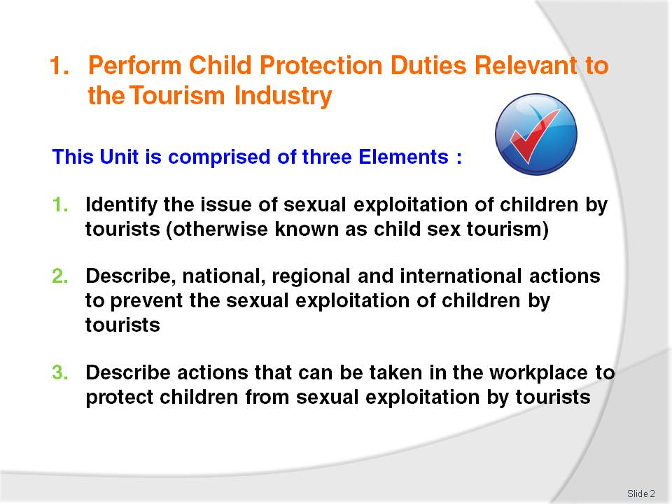
Slide No | Trainer Notes
Trainer advises students that this Unit comprises three Elements, as listed on the slide explaining:
Each Element comprises a number of Performance Criteria which will be identified throughout the class and explained in detail
Students can obtain more detail from their Trainee Manual
The course presents advice and information but, where their workplace requirements differ to what is presented, the workplace practices and standards must be observed.

Slide
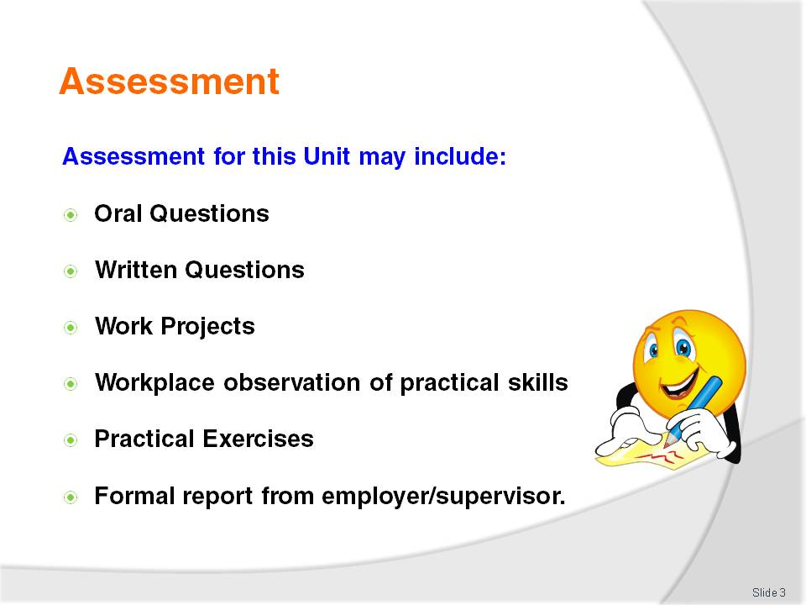
Slide No | Trainer Notes
Trainer advises students that assessment for this Unit may take several forms all of which are aimed at verifying they have achieved competency for the Unit as required.
Trainer indicates to students the methods of assessment that will be applied to them for this Unit.

Slide
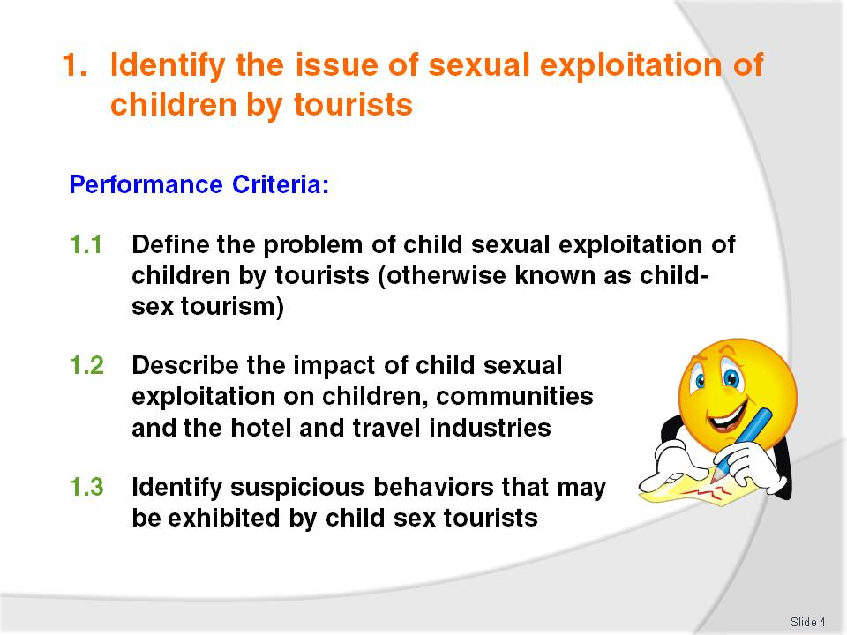
Slide No | Trainer Notes
 | Trainer identifies for students the Performance Criteria for this Element, as listed on the slide.

Slide
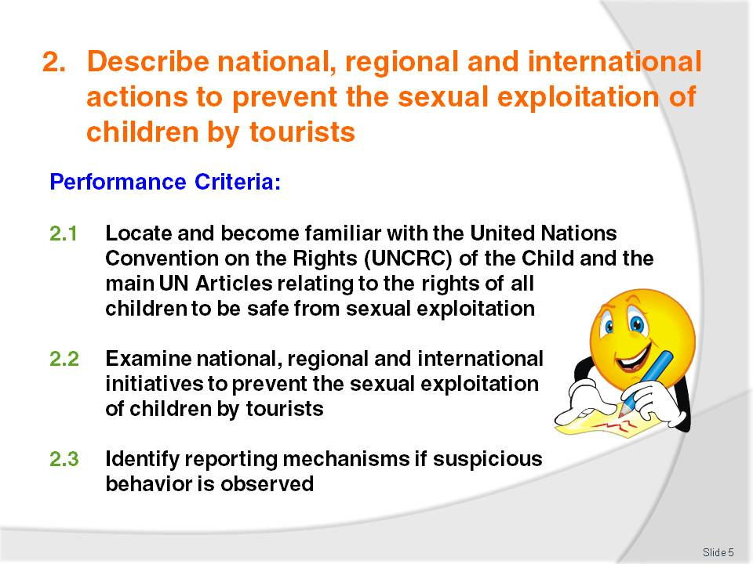
Slide No | Trainer Notes
 | Trainer identifies for students the Performance Criteria for this Element, as listed on the slide.

Slide
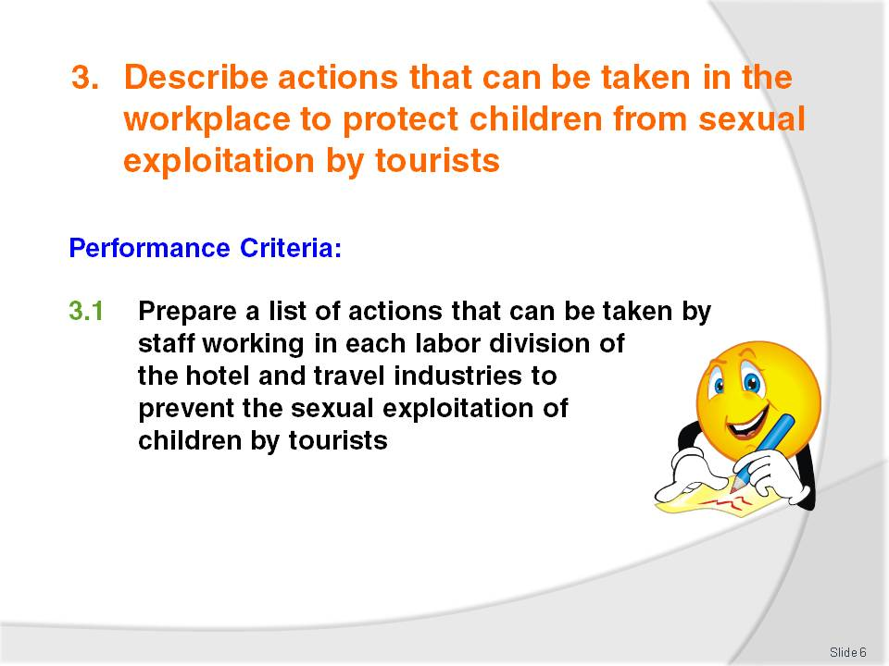
Slide No | Trainer Notes
Trainer identifies for students the Performance Criteria for this Element, as listed on the slide.
Class Activity – General discussion
Trainer leads a general class discussion on responding to Child Sex Tourism in the workplace asking questions such as:
Are you aware of Child Sex Tourism in your workplace, local area or region?
If yes, how prevalent do you believe Child Sex Tourism is in your workplace, local area or region?
Are you aware of local and international laws regarding Child Sex Tourism?
How important is it for the hotel and travel industries to introduce child protection measures across all areas of the workplace?
Does your workplace currently have policies, procedures and training in place to identify and eliminate Child Sex Tourism from your workplace? If yes, please describe.

Slide
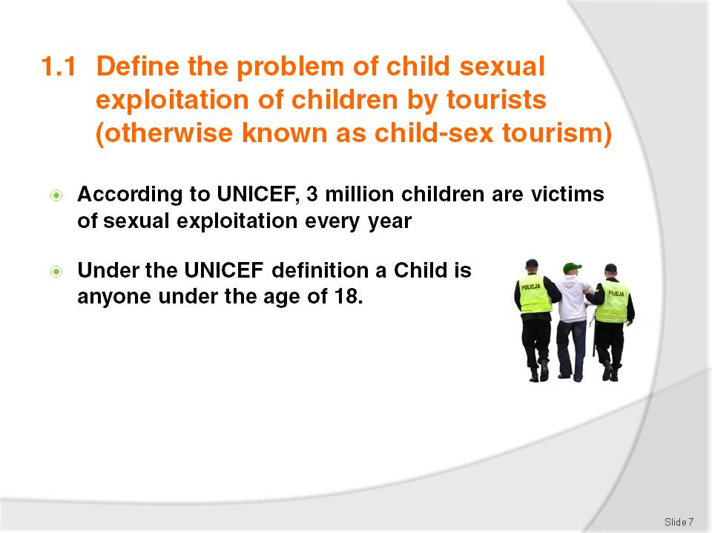
Slide No | Trainer Notes
Trainer to discuss the above points
Trainer to explain that if the ‘definition of a child’ is younger than the age of 18 in the country where you operate then you must follow the local definition.

Slide
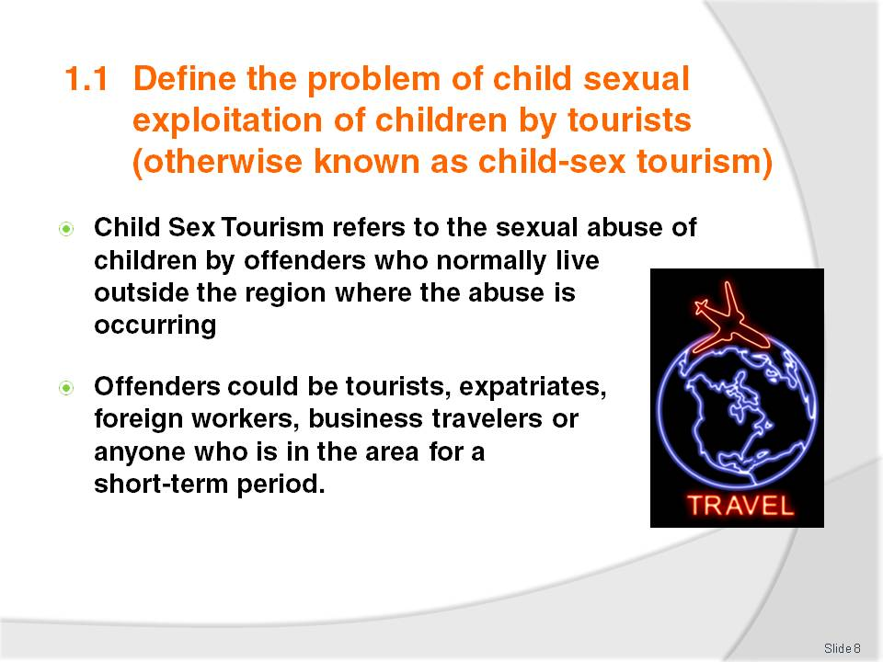
Slide No | Trainer Notes
Trainer to refer students to the Training Manual for a more detailed definition of Child Sex Tourism
Trainer to discuss the above points
Activity: It is suggested that the Trainer download and go through with the students the Childwise Free Downloadable Publication, ‘Wise Up’ to Child Sexual Abuse available at:
- http://www.childwise.net/Resources/online-publications.html.

Slide
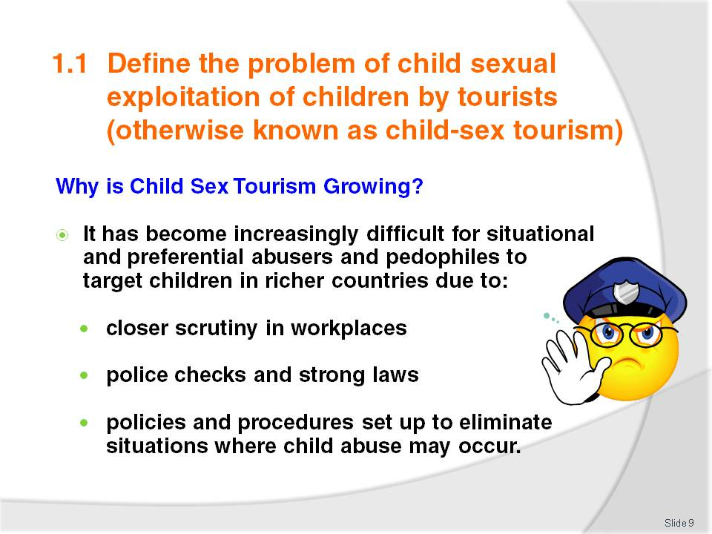
Slide No | Trainer Notes
Trainer to explain that, due to the above reasons, child sex offenders are now looking to less developed countries to access vulnerable children
Trainer to discuss the above points.

Slide
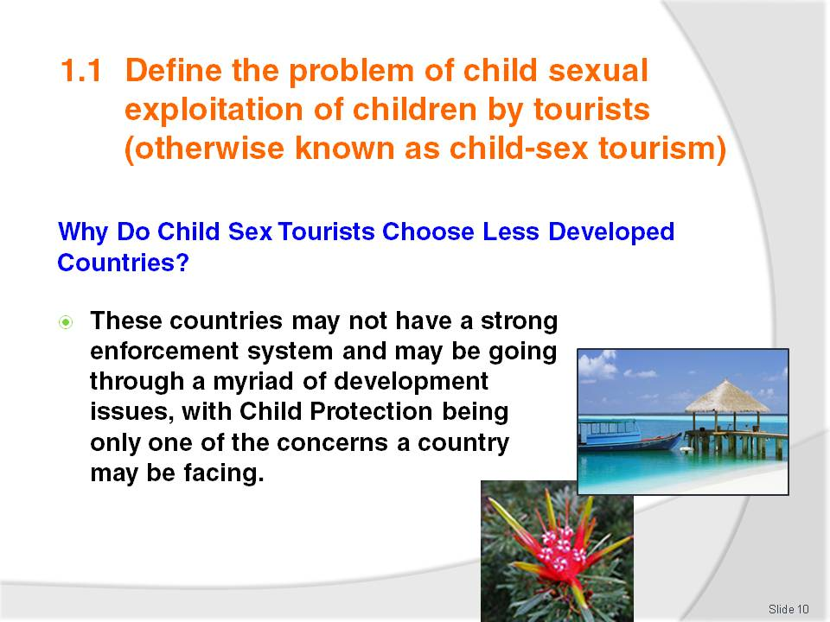
Slide No | Trainer Notes
Trainer to explain that ‘In the past many of these offenders have found themselves in positions of power where they can access children freely but due to a stronger commitment to stamp out child abuse in their own countries, they are now moving to areas where there are vulnerable children and perhaps lax law enforcement and corruption’
Trainer to discuss the above points.

Slide
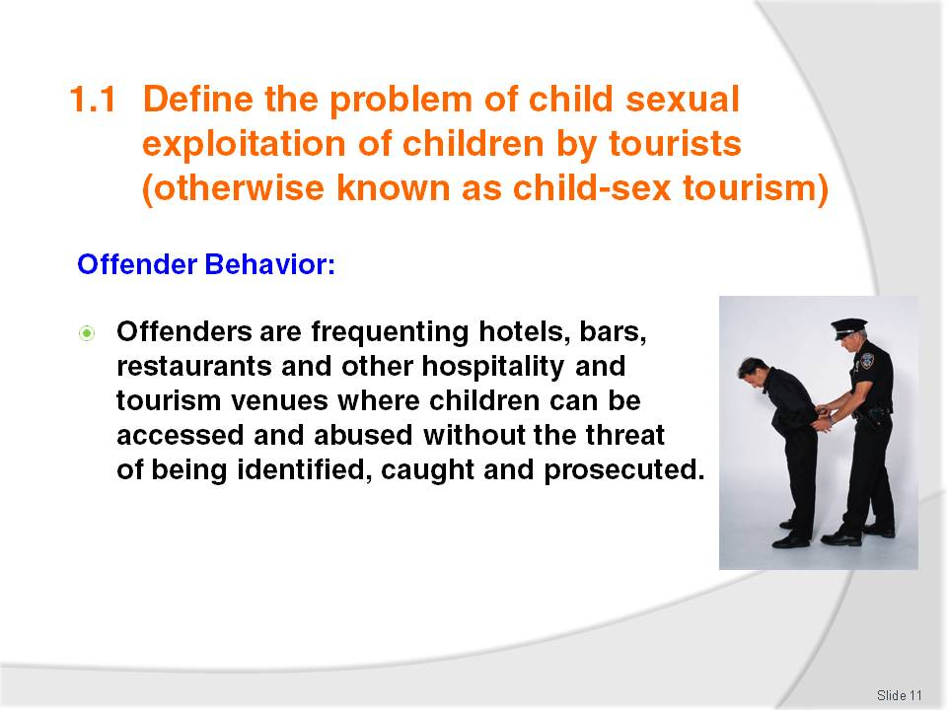
Slide No | Trainer Notes
 | Trainer to discuss the above point.

Slide
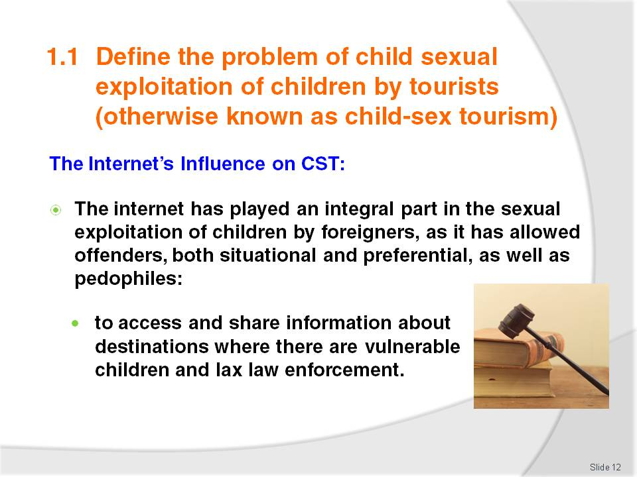
Slide No | Trainer Notes
Trainer to explain that ‘The internet has also allowed these offenders to form networks that keep each other up to date about ‘new’ destinations where children can be accessed easily as well as allowing offenders to share videos and photographs of abused children’
Trainer to discuss the above points.

Slide
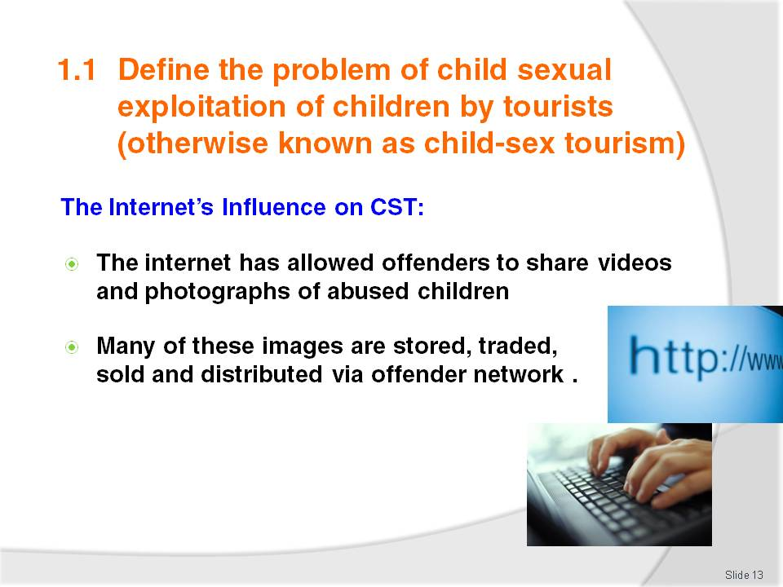
Slide No | Trainer Notes
 | Trainer to discuss the above points.

Slide
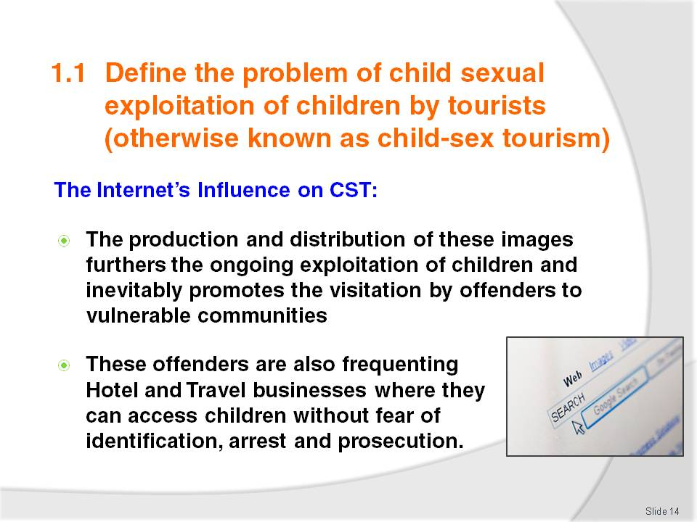
Slide No | Trainer Notes
 | Trainer to discuss the above points.

Slide
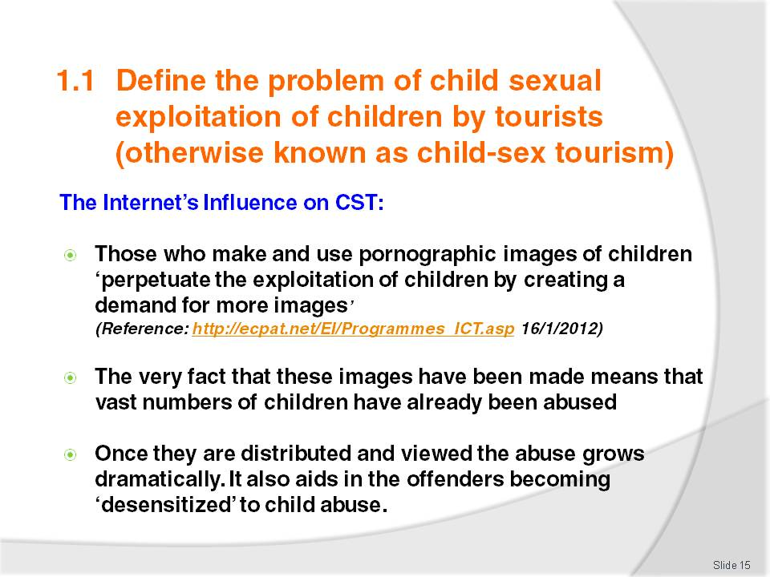
Slide No | Trainer Notes
 | Trainer to discuss the above points.

Slide
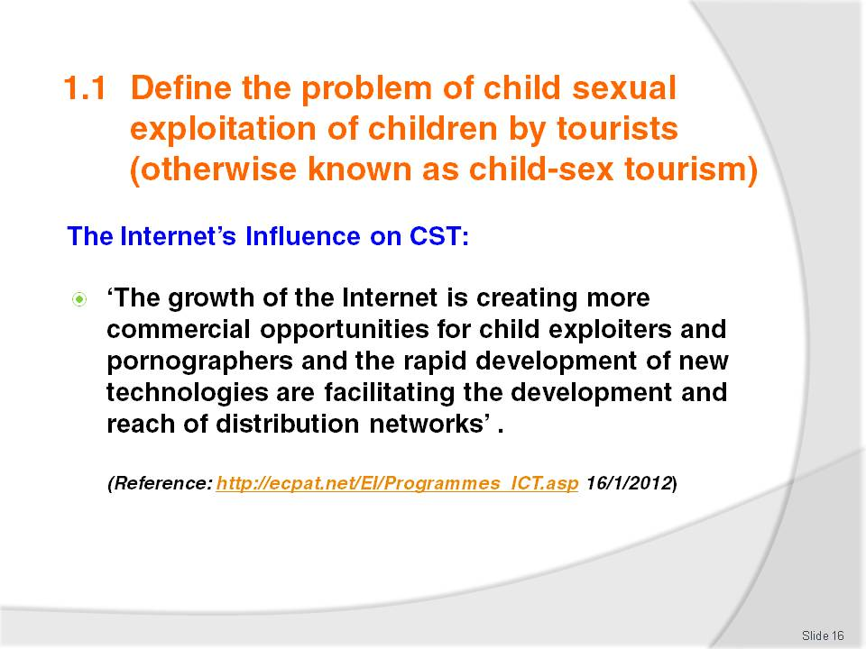
Slide No | Trainer Notes
 | Trainer to discuss the above points.

Slide
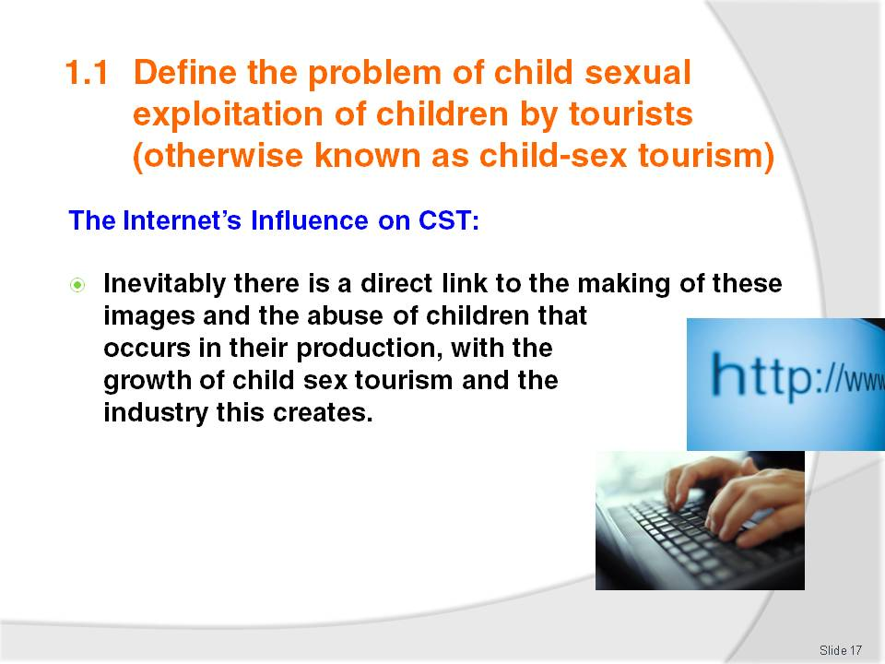
Slide No | Trainer Notes
Please ask the students not to search for child pornography on the internet as an exercise to see if it actually exists and is assessable as this may lead to them being investigated and also acts as a form of voyeurism that perpetuates the existence of child pornography on the internet
Trainer to discuss the above point.
Activity:
Trainer to discuss with the class what is it about the internet that has allowed the CSEC and CST to grow.

Slide
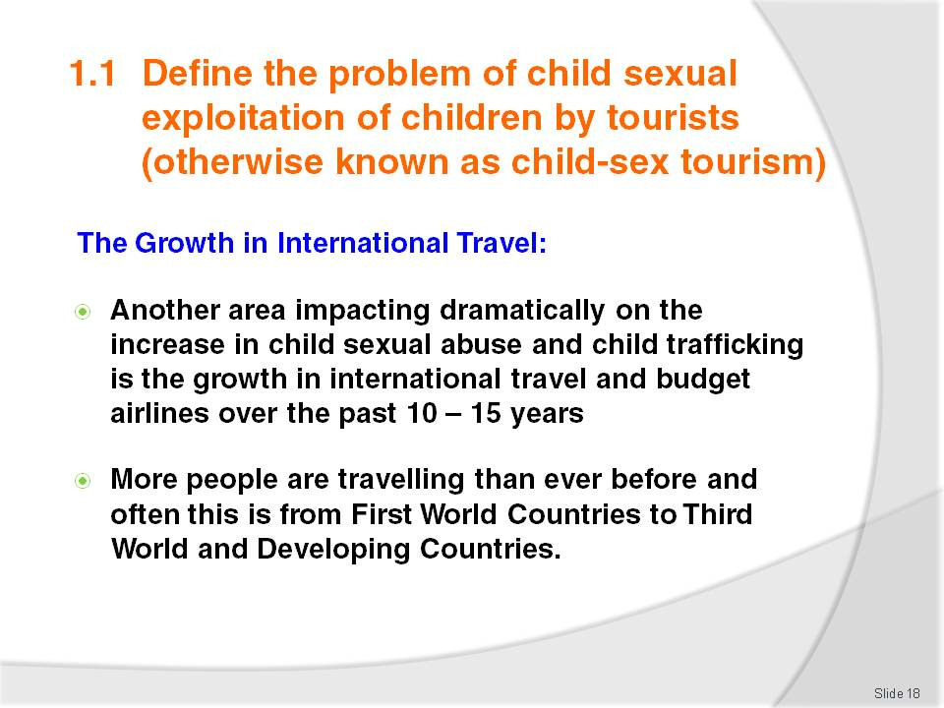
Slide No | Trainer Notes
Trainer to discuss the above points
Trainer to explain that due to the above ‘This has led to an explosion in the sexual abuse of children, as more and more offenders are accessing vulnerable children in these new budget destinations’.

Slide
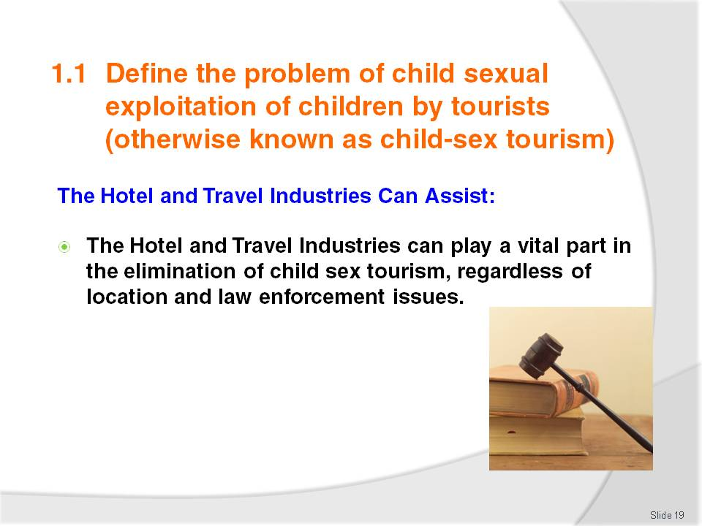
Slide No | Trainer Notes
 | Trainer to discuss the above points.

Slide
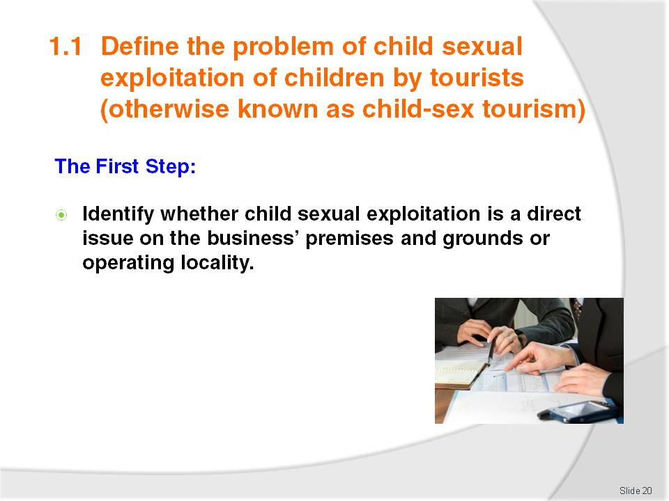
Slide No | Trainer Notes
 | Trainer to discuss the above point.

Slide
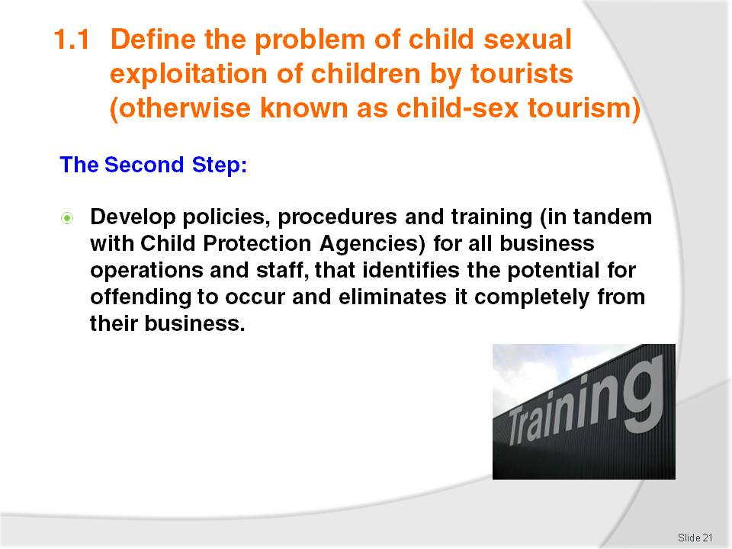
Slide No | Trainer Notes
 | Trainer to discuss the above point.

Slide
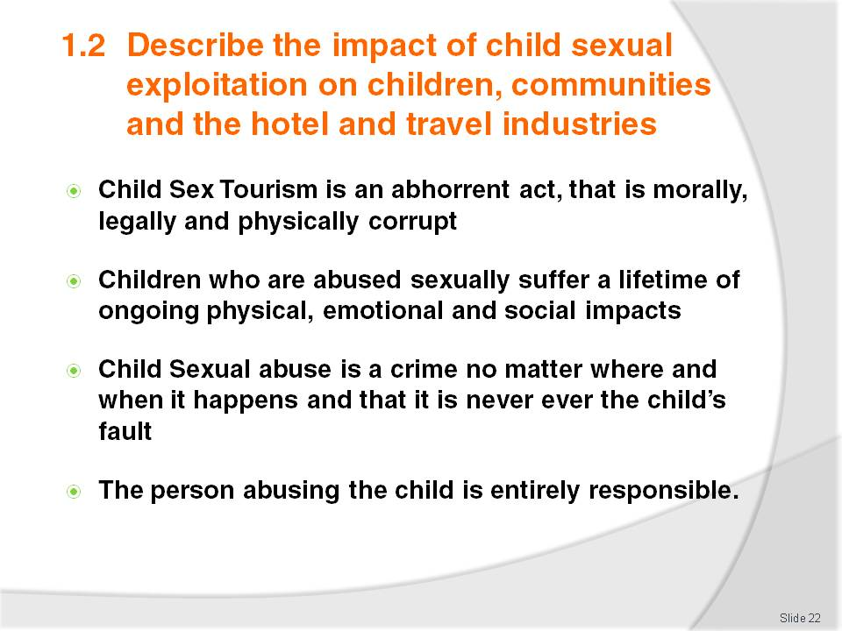
Slide No | Trainer Notes
Trainer to discuss the above points
Trainer to discuss that children are just that and that the offender has all the power and influence, regardless of the child’s behaviour or life situation.

Slide
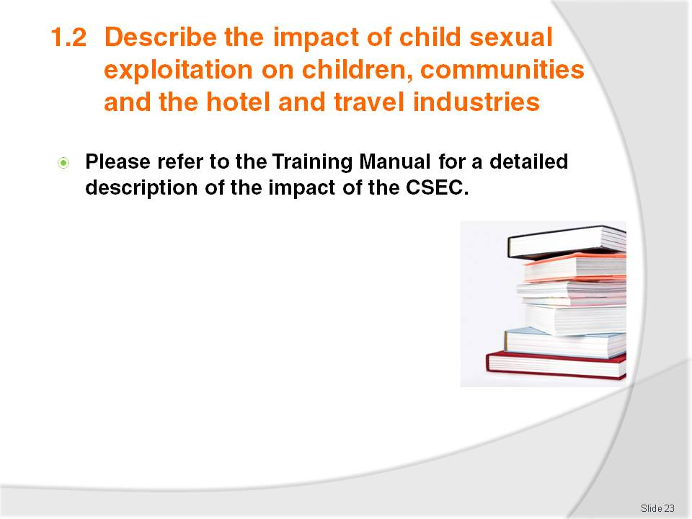
Slide No | Trainer Notes
 | Trainer to refer the class to the Training Manual and discuss each point with students.

Slide
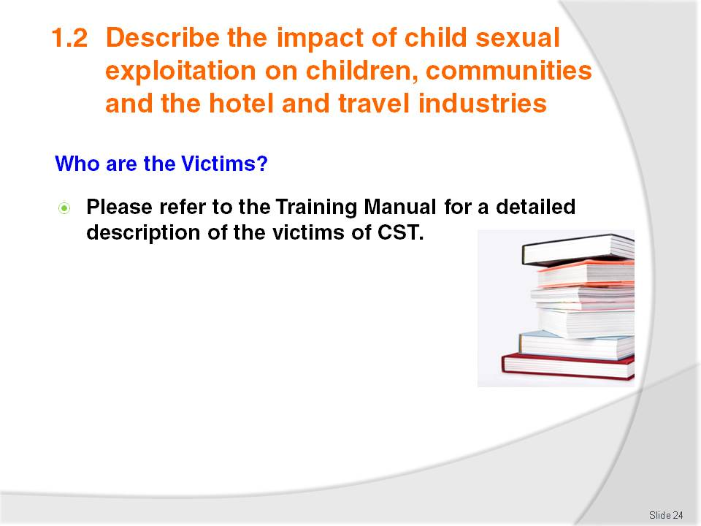
Slide No | Trainer Notes
 | Trainer to refer the class to the Training Manual and discuss each point in class.

Slide
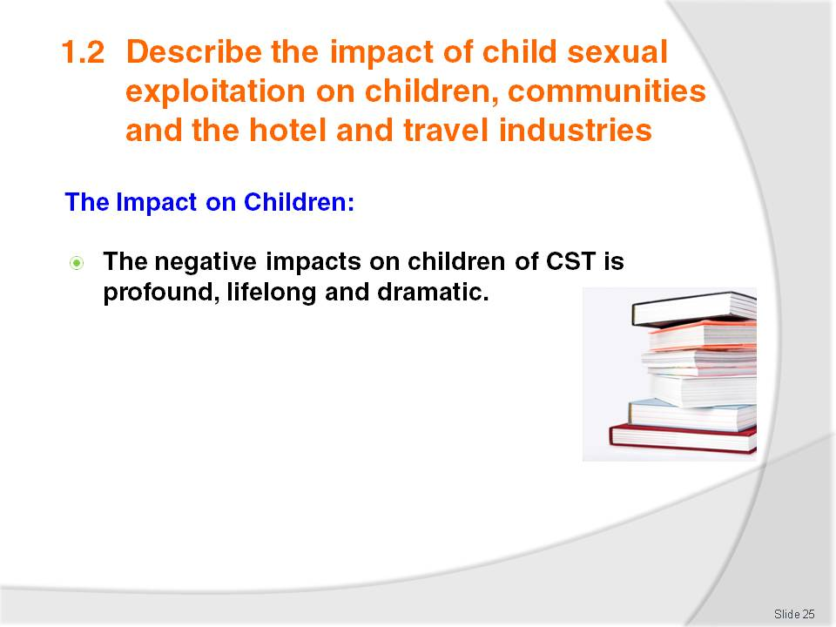
Slide No | Trainer Notes
 | Trainer to discuss the above points.

Slide
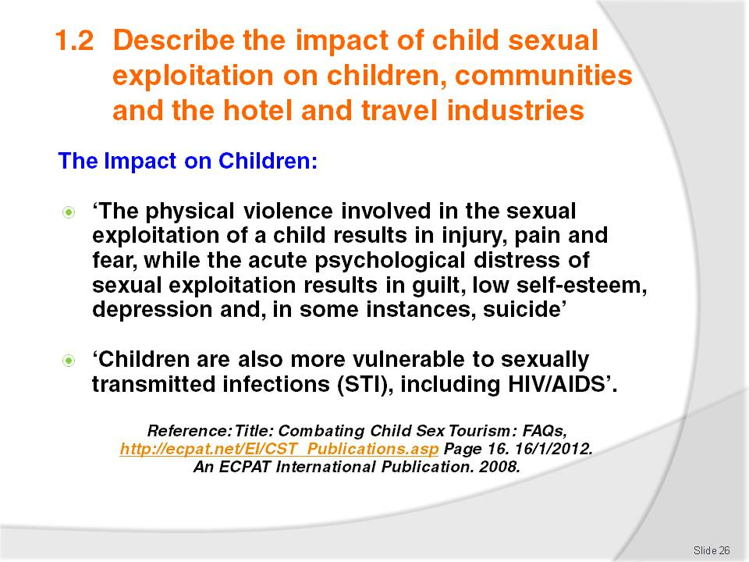
Slide No | Trainer Notes
 | Trainer to discuss the above points.

Slide
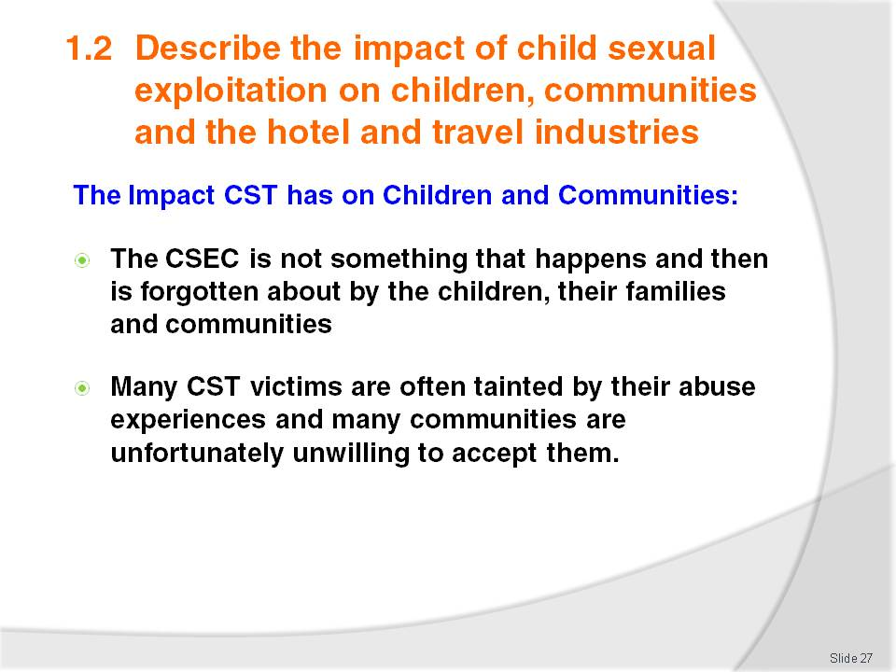
Slide No | Trainer Notes
Trainer to explain that, due to the above, this inevitably leads to the further breakdown of families and communities
Trainer to discuss the above points.

Slide
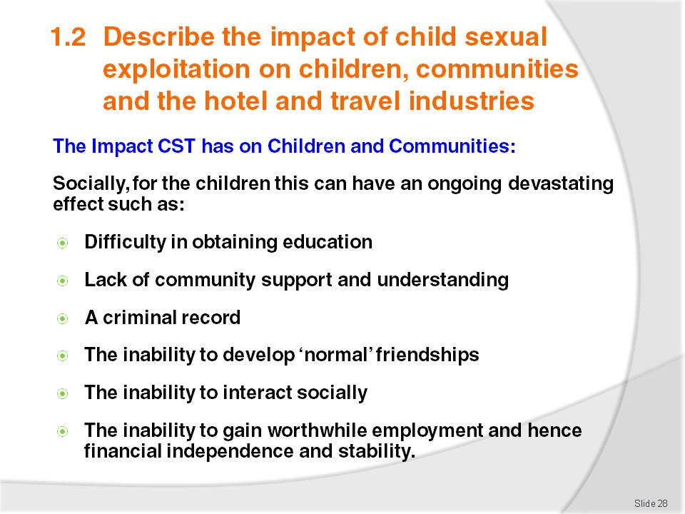
Slide No | Trainer Notes
Trainer to discuss the above points.
Activity:
Trainer to discuss each of the above points with the class and ask why each of these may be an issue for an abused child or an adult that was abused as a child.

Slide
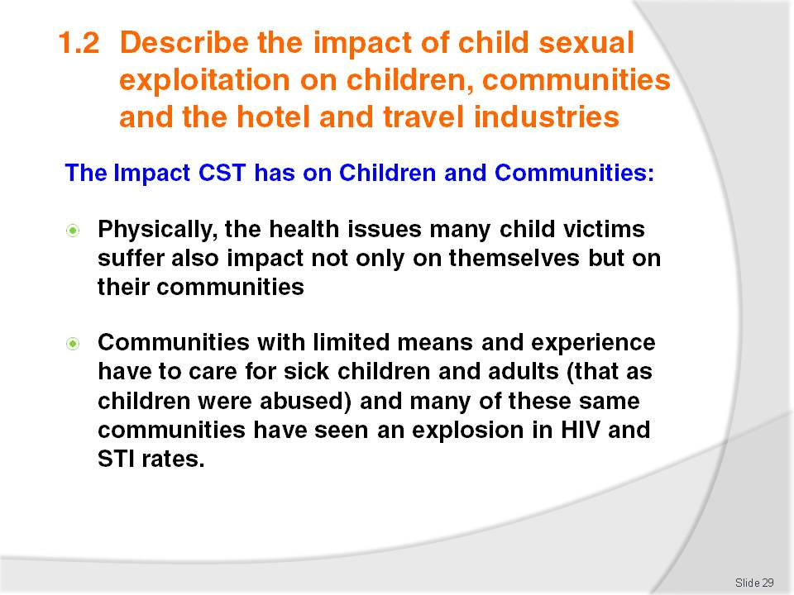
Slide No | Trainer Notes
 | Trainer to discuss the above points.

Slide
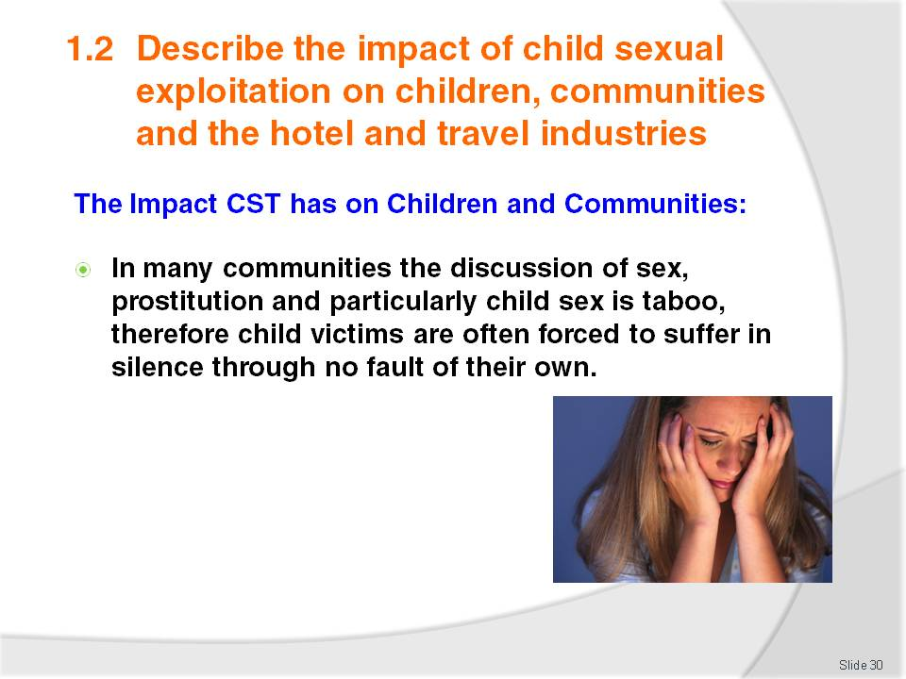
Slide No | Trainer Notes
Trainer to discuss the above points
Activity:
Trainer to discuss with class whether the discussion of sex is taboo in their local communities. If so, what ways that are culturally appropriate could be used to discuss the issue of CST and the CSEC?

Slide
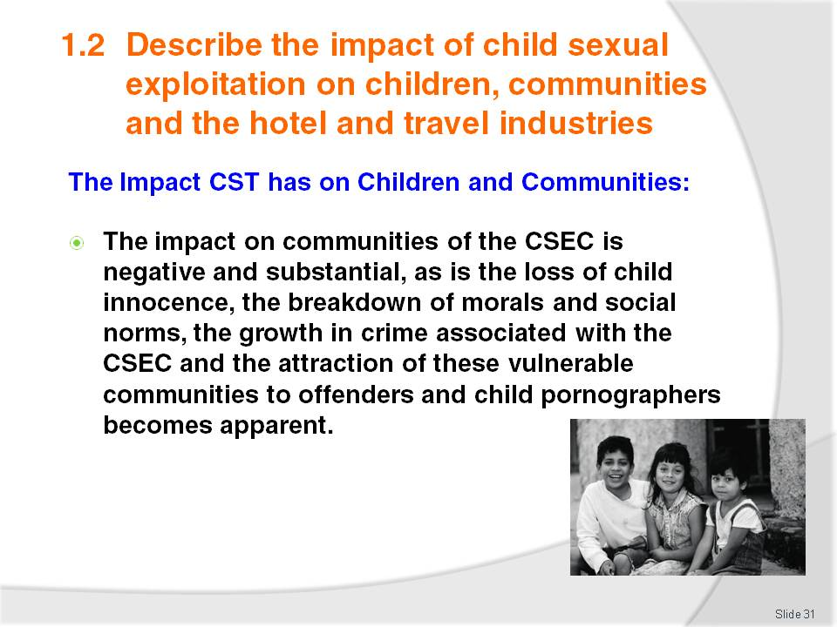
Slide No | Trainer Notes
 | Trainer to discuss the above point.

Slide
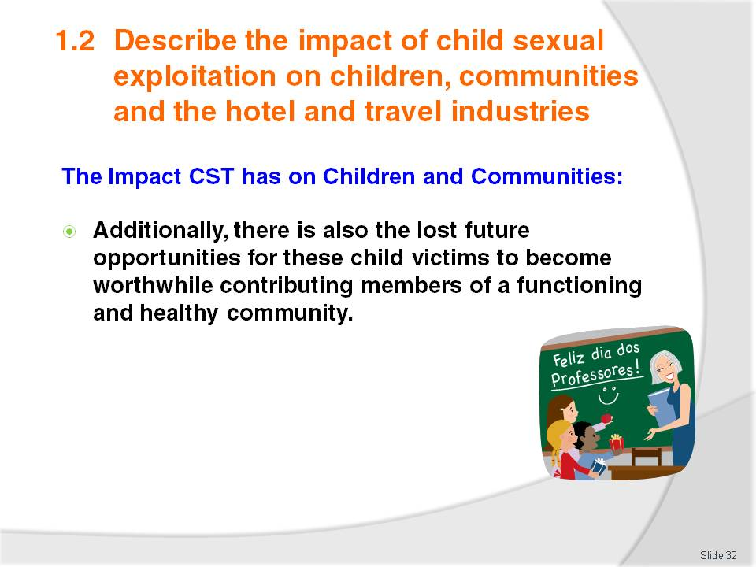
Slide No | Trainer Notes
Trainer to discuss the following points based on the above description:
- Child victims of sexual abuse need to be protected, supported and provided with ongoing health care and educational opportunities
- However, all of these options are costly and can never undo the harm
- The best course of action for a community and the Hotel and Travel Industry within those communities is to work towards the elimination of CST before the impacts are felt by all concerned.

Slide
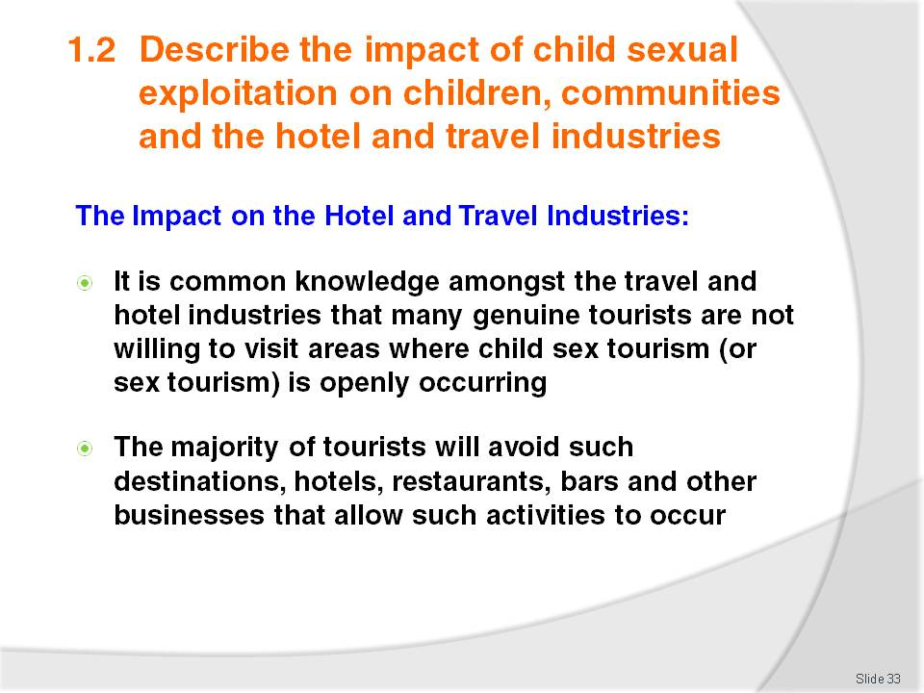
Slide No | Trainer Notes
 | Trainer to discuss the above points.

Slide
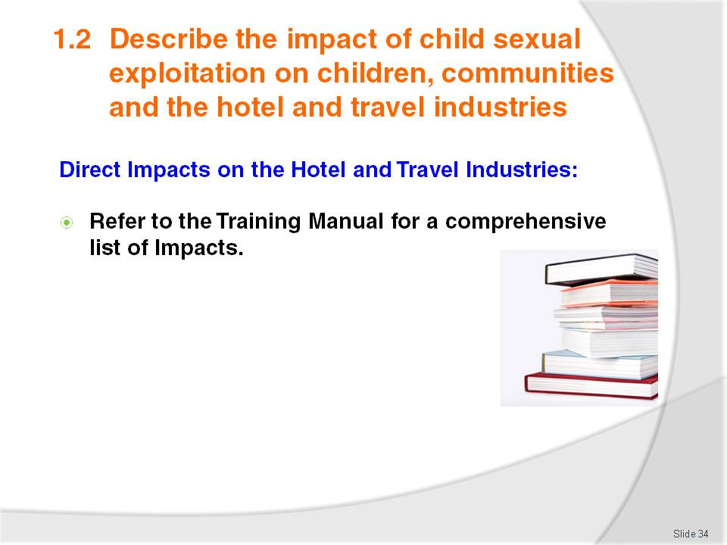
Slide No | Trainer Notes
Refer students to the Training Manual for a comprehensive list of Impacts and discuss each point in detail asking the students why they think that each of these points will impact on the Hotel and Travel Industries?
Other Suggestions for the above: include showing the students Trip Advisor Reviews and copies of Newspaper and Magazine articles regarding Child Sex Tourism.

Slide
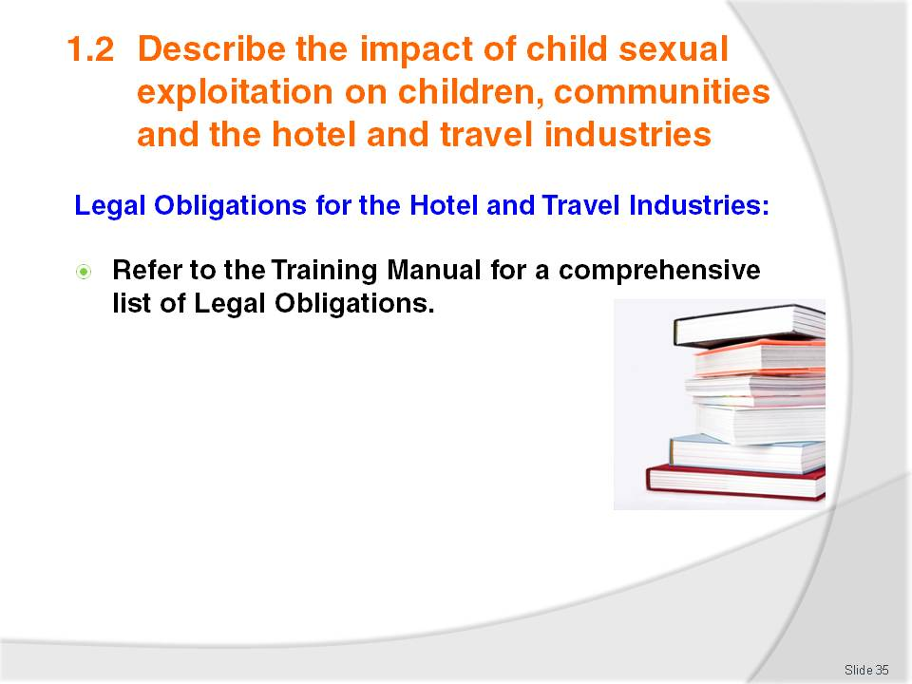
Slide No | Trainer Notes
 | Trainer to direct students to the Training Manual and take students through each of the legal obligations explaining each point as necessary.

Slide
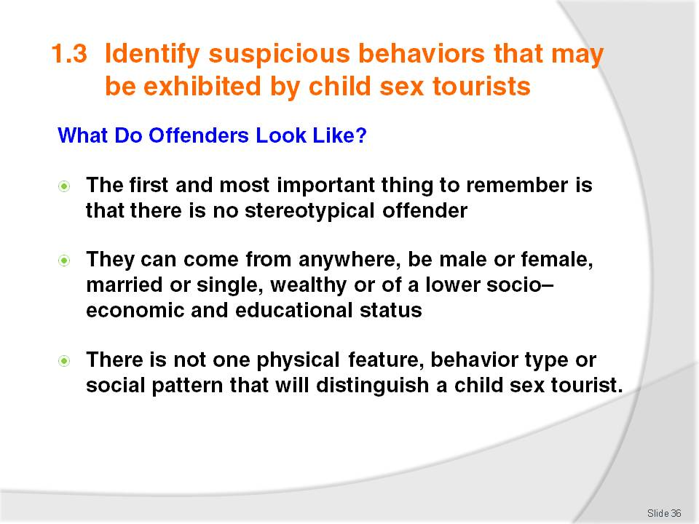
Slide No | Trainer Notes
 | Trainer to discuss the above points.

Slide
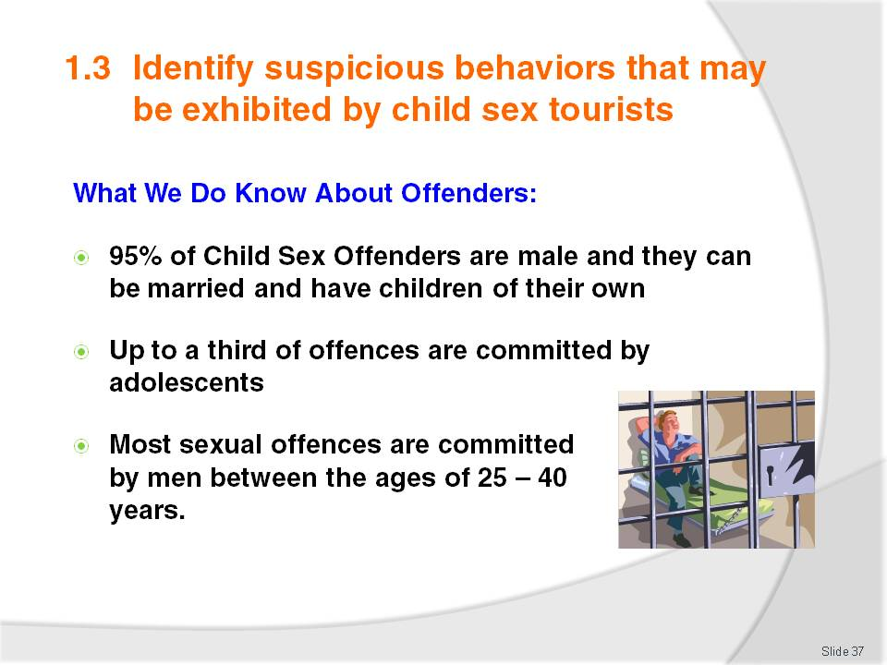
Slide No | Trainer Notes
 | Trainer to discuss the above points.

Slide
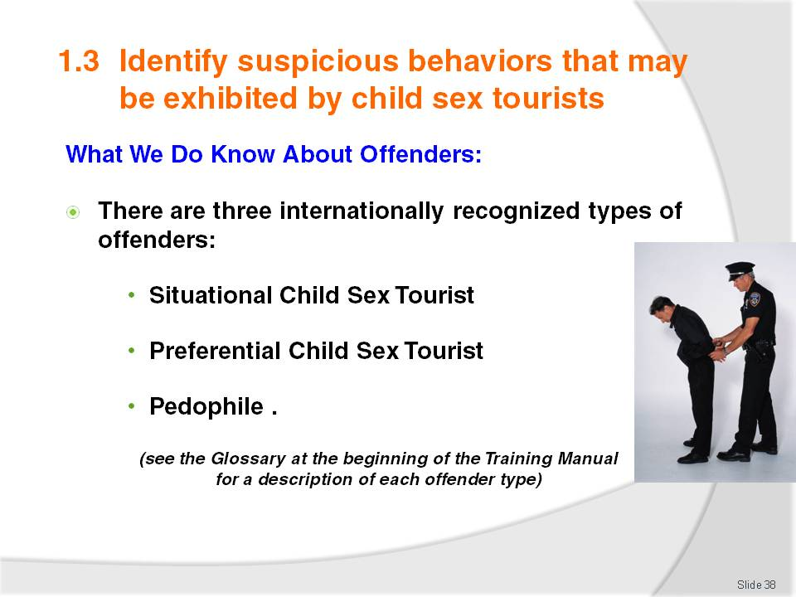
Slide No | Trainer Notes
 | Trainer to discuss the above points and refer class to the Glossary of the Training Manual for a description of each offender type.

Slide
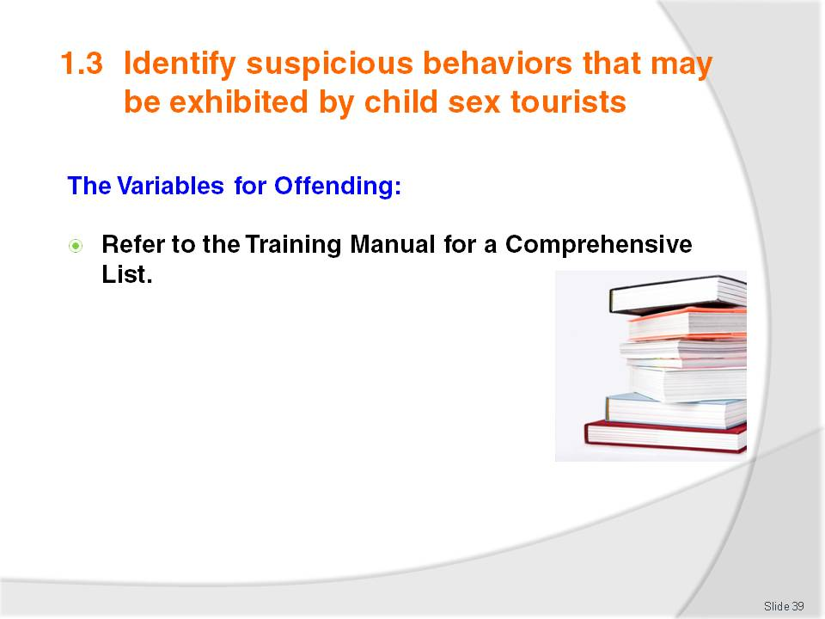
Slide No | Trainer Notes
Trainer to refer class to the Training Manual for a description of each offender type
Trainer to discuss each Variable and ask the class ‘why do each of these variables impact on CST’s growth?’

Slide
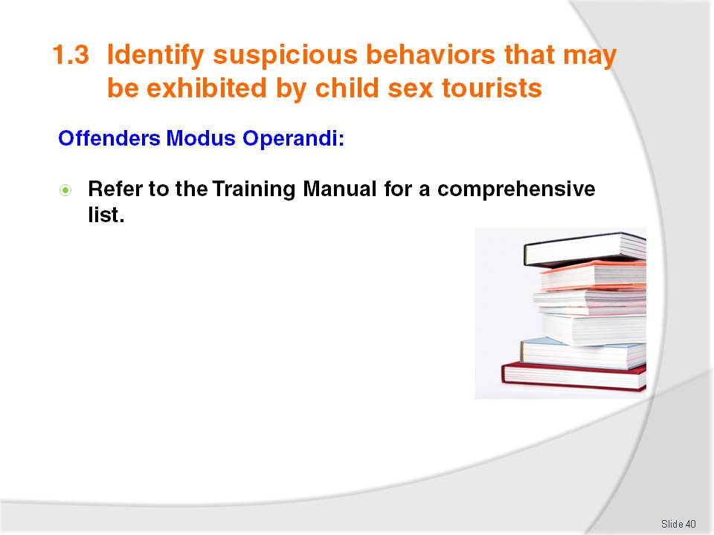
Slide No | Trainer Notes
Trainer to refer class to the Training Manual for a description of an offender’s Modus Operandi
Trainer to discuss each Variable and ask the class ‘why do each of these variables impacts on CST’s growth?’

Slide
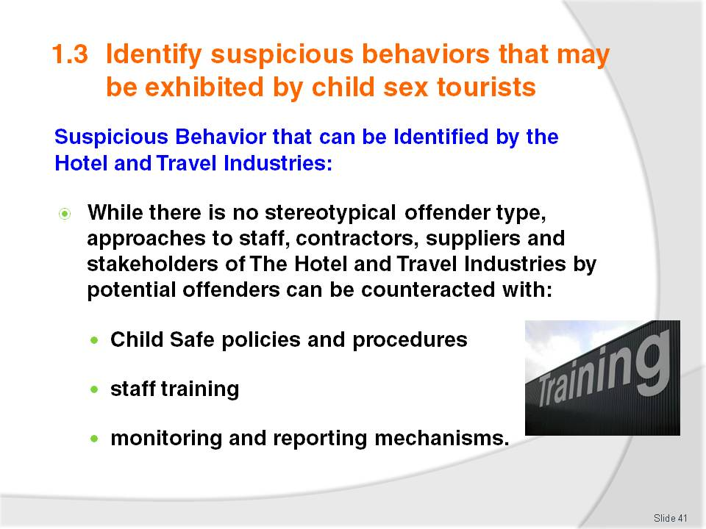
Slide No | Trainer Notes
 | Trainer to discuss the above points.

Slide
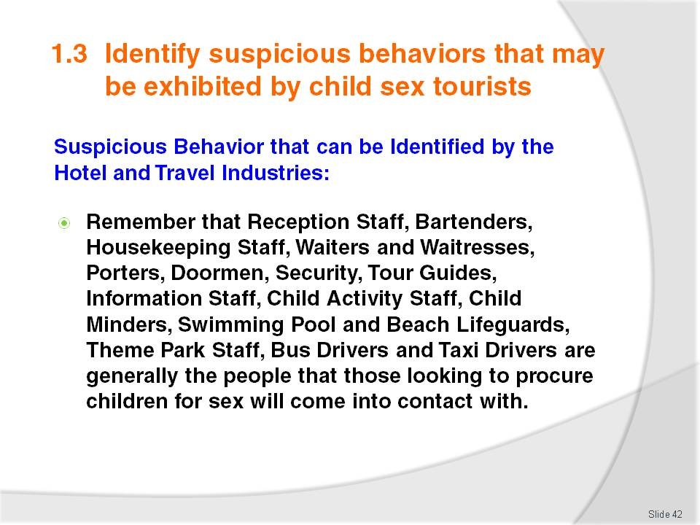
Slide No | Trainer Notes
 | The Trainer could ask the class if there are any other positions in the Hotel and Travel Industries that are not included on the list above.

Slide
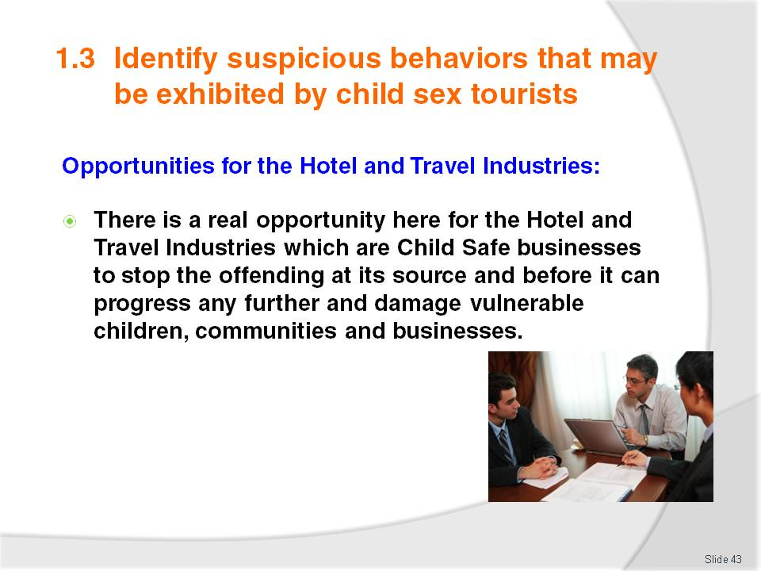
Slide No | Trainer Notes
 | Trainer to discuss the above point.

Slide
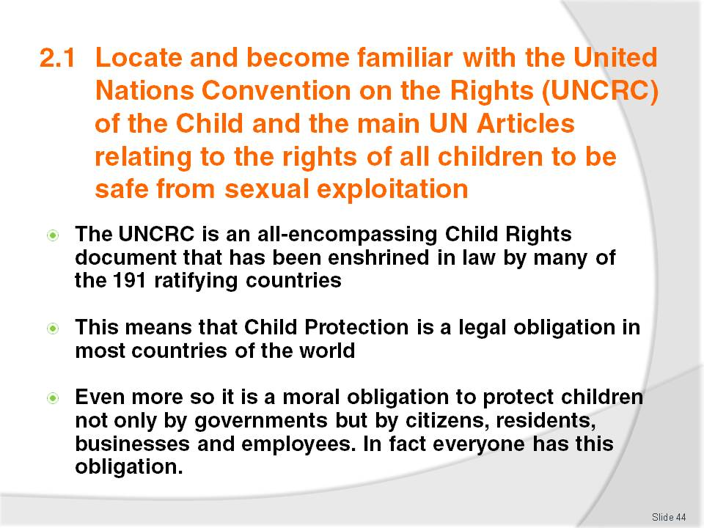
Slide No | Trainer Notes
The Trainer should familiarize themselves with the United Nations Convention on the Rights of the Child, particularly Articles 19, 27, 31, 32, 34 and 35 and refer students to the Training Manual for a detailed breakdown of each Article
The United Nations Convention on the Rights of the Child can be found here:
- http://www.crin.org/docs/resources/treaties/uncrc.asp#Thirty_four.
Activity 2:
If time permits it is suggested that the Trainer also take the students through each of the above suggested articles and relate the importance of the Hotel and Tourism Industries adhering to these laws in their workplaces, business operations and dealings with customers.

Slide
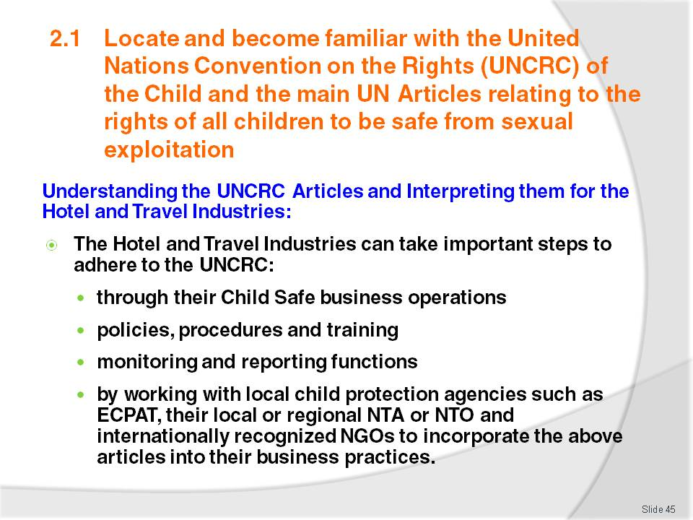
Slide No | Trainer Notes
 | Trainer to discuss the above points.

Slide
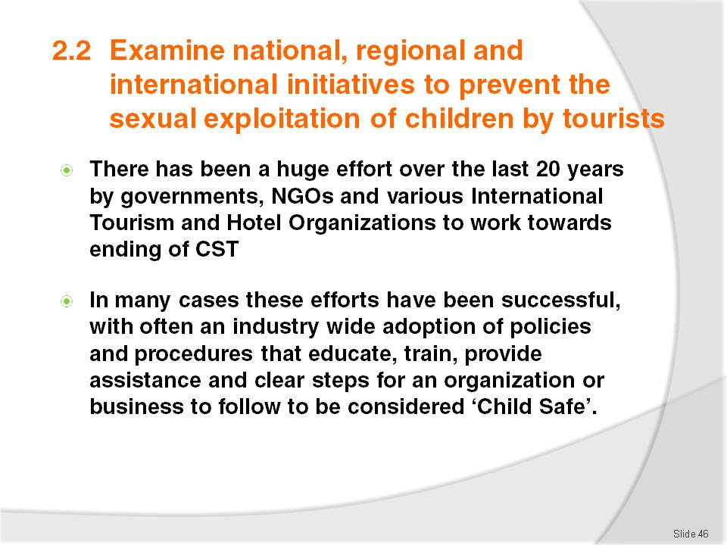
Slide No | Trainer Notes
 | Trainer to discuss the above points.

Slide
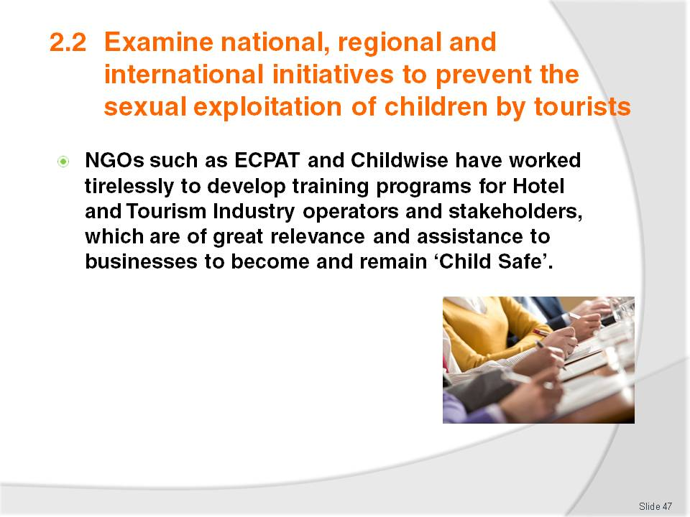
Slide No | Trainer Notes
 | Trainer to discuss above points.

Slide
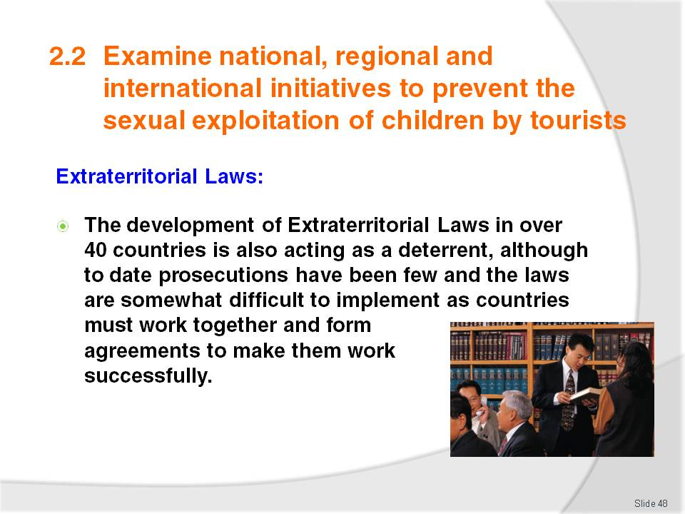
Slide No | Trainer Notes
It is suggested that the Trainer show students the following website:
- http://www.thefuturegroup.org/youwillbecaught/laws.html
This is a very good resource website that contains information on which countries have Extraterritorial Laws, has a ‘Report an Offender’ page, a list of international Partners who are fighting the CSEC, information on Health Issues and on Offenders who have been caught and prosecuted.
Activity:
Break the students into groups of 3 – 4 and then if internet access is available give each of the groups one of the examples listed in the Training Manual and ask them to research this particular Global Effort and to report back to the class on their findings
If internet access is unavailable the Trainer can download information from these sites and prepare information packs on each of these Global Efforts to give to the students to complete this activity
20 - 30 Minutes should be more than enough time for the Research part of this Activity.

Slide
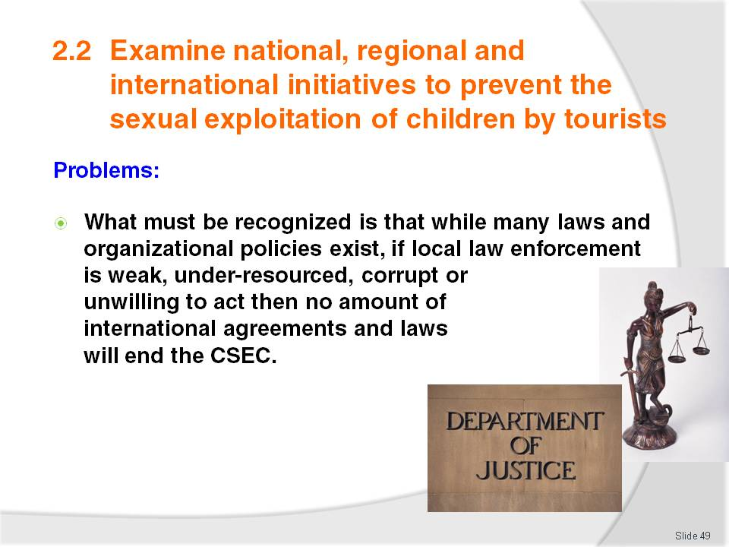
Slide No | Trainer Notes
 | Trainer to discuss the above point.

Slide
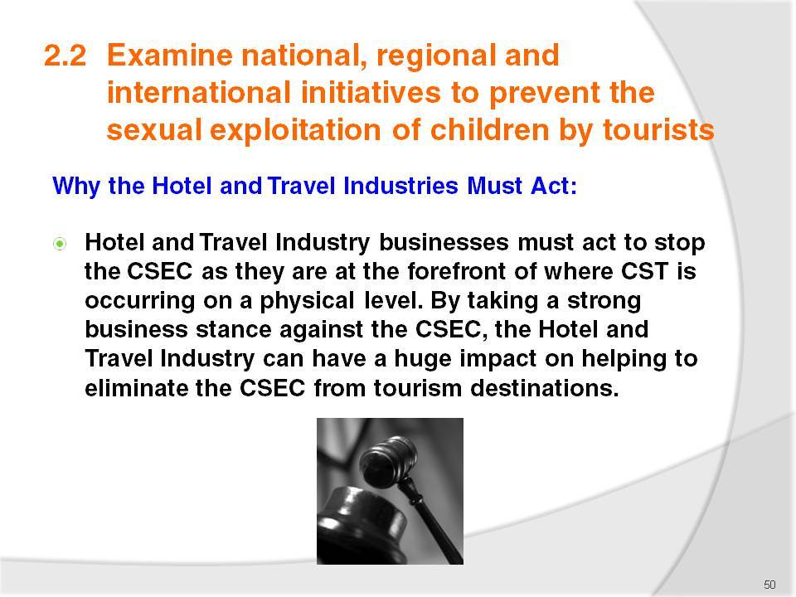
Slide No | Trainer Notes
 | Trainer to discuss the above points.

Slide
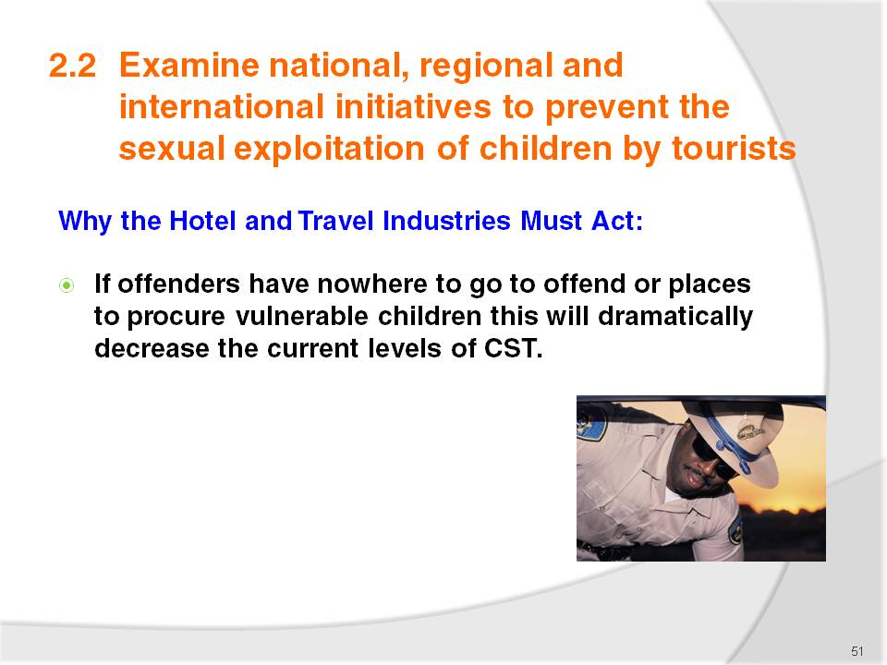
Slide No | Trainer Notes
 | Trainer to discuss the above points.

Slide
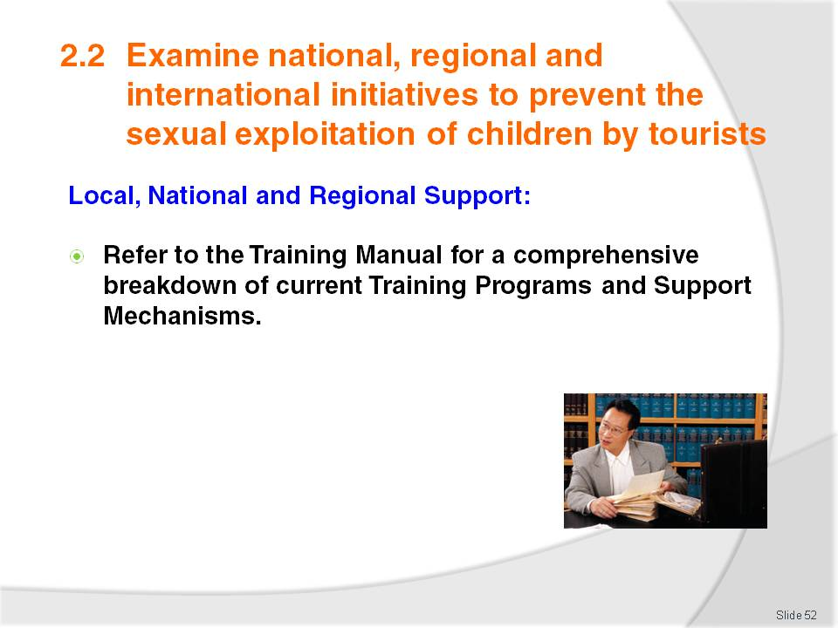
Slide No | Trainer Notes
Trainer Notes and Activity:
Trainer to refer class to the Training Manual and go through each of the Support examples shown
The Trainer could research local, national and regional organizations and prepare a Handout Pack of this information for students.

Slide
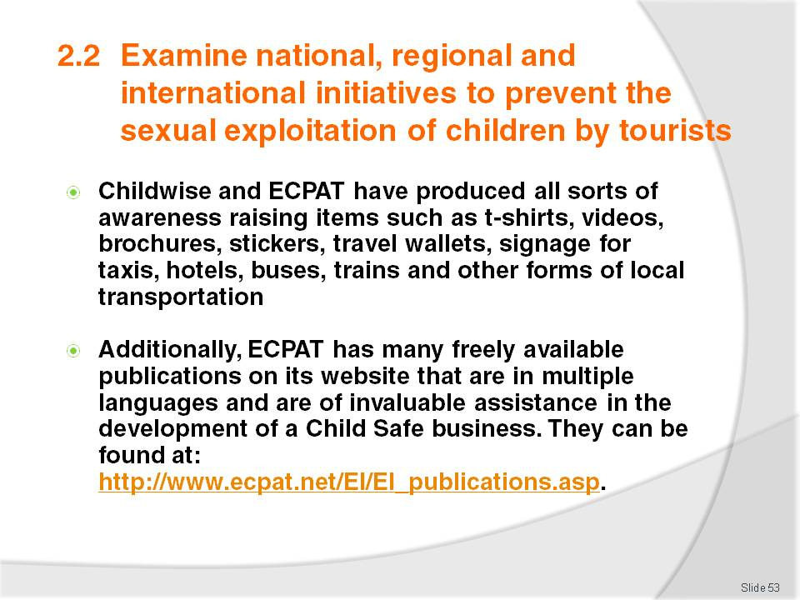
Slide No | Trainer Notes
Trainer Notes and Activity:
Trainer to discuss the above points
Trainer could access some of the local awareness raising items available and distribute to the class, asking the class if they had seen them anywhere before and where would be the best place to locate them in their workplaces?

Slide
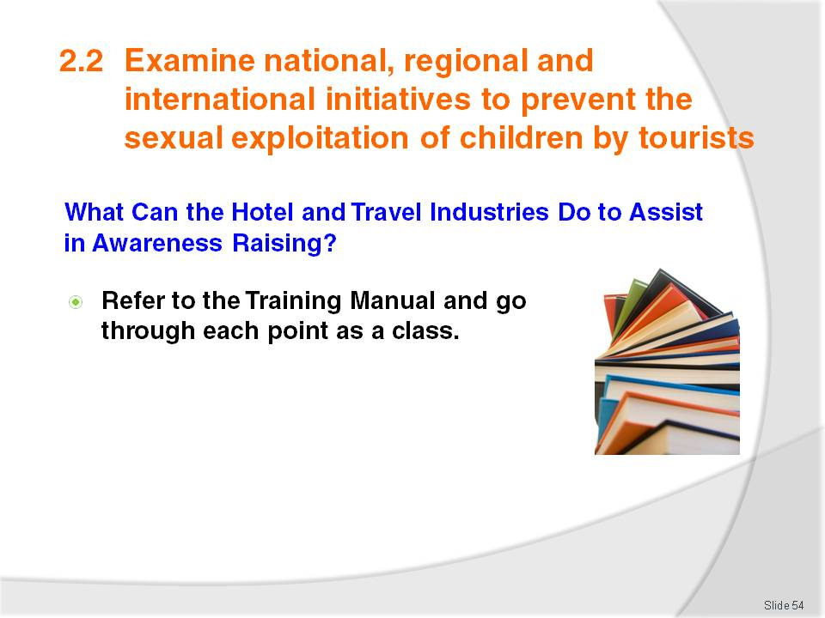
Slide No | Trainer Notes
 | Trainer to refer students to the Training Manual and go through each point with the class asking them do their businesses already do these things? If not could they?

Slide
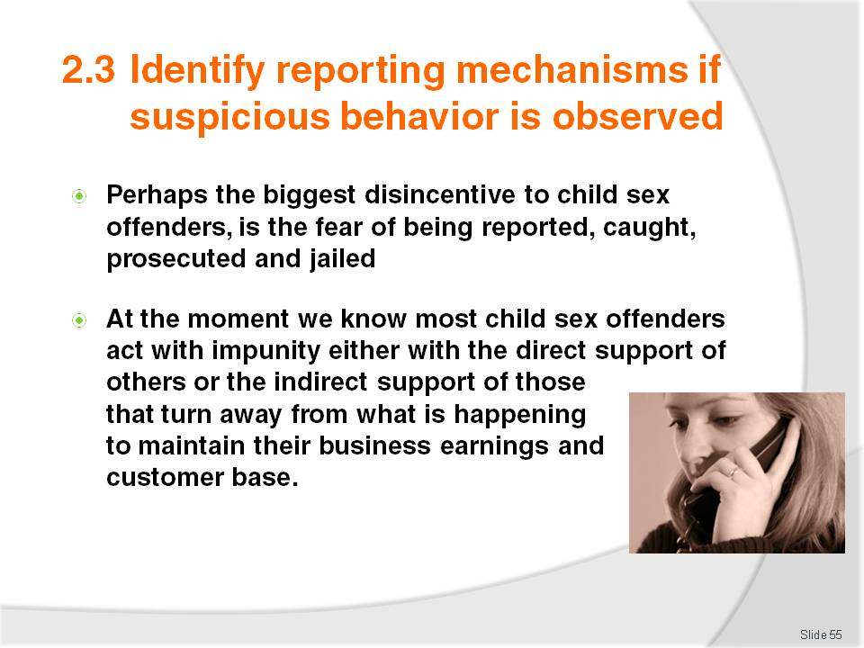
Slide No | Trainer Notes
 | Trainer to discuss the above points.

Slide
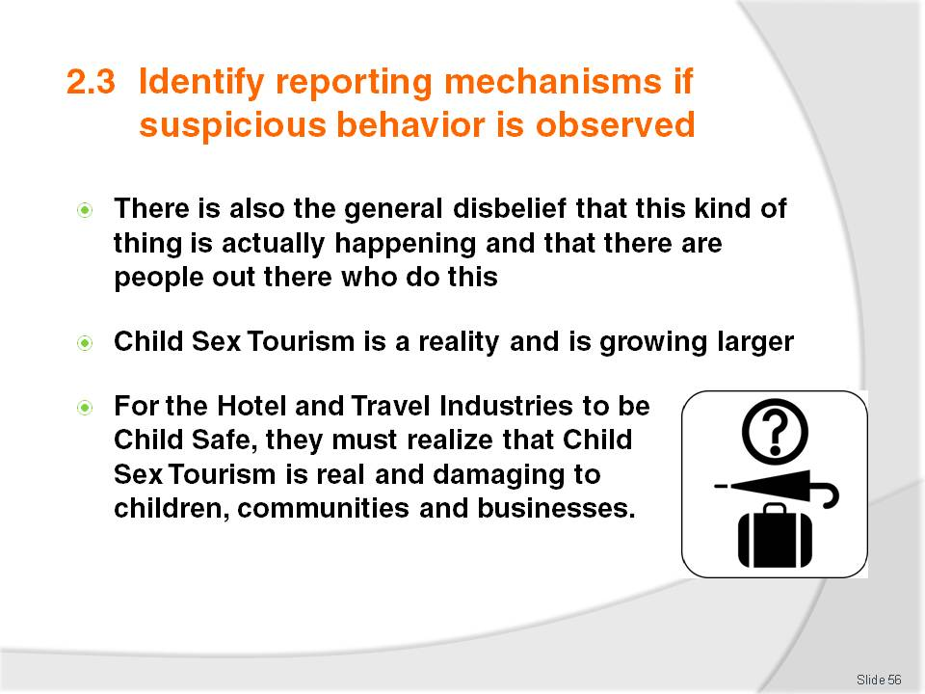
Slide No | Trainer Notes
 | Trainer to discuss the above points.

Slide
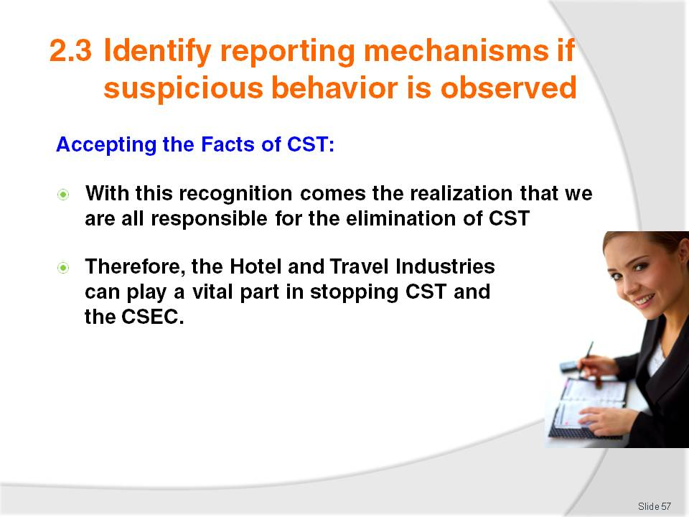
Slide No | Trainer Notes
 | Trainer to discuss the above points.

Slide
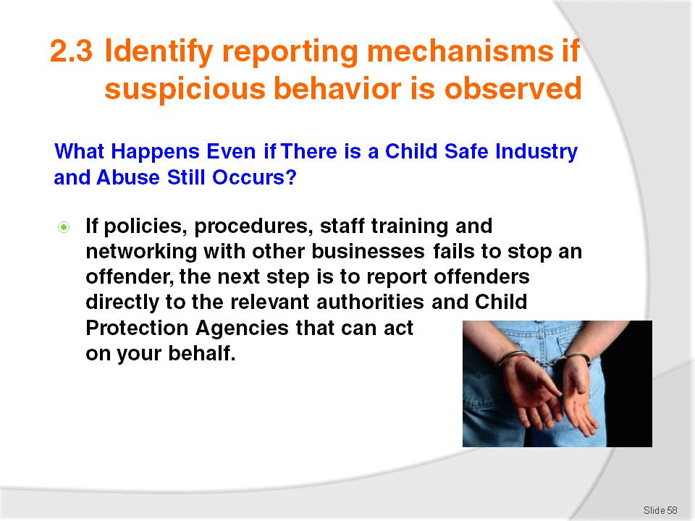
Slide No | Trainer Notes
 | Trainer to discuss the above points.

Slide
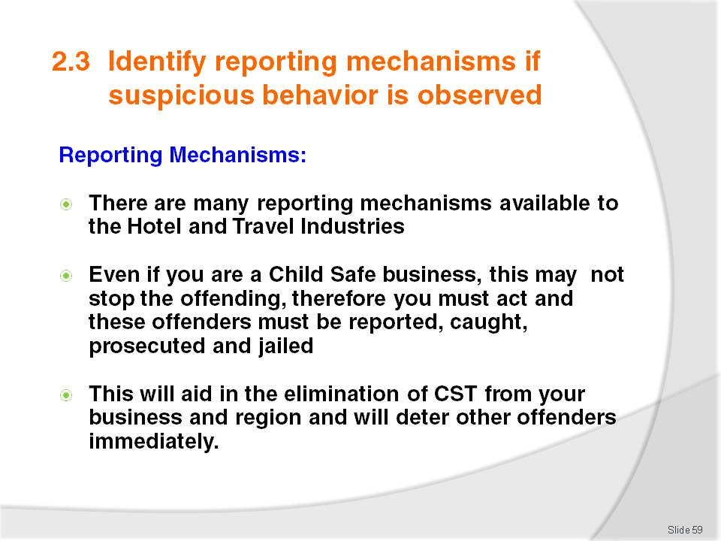
Slide No | Trainer Notes
 | Trainer to discuss the above points.

Slide
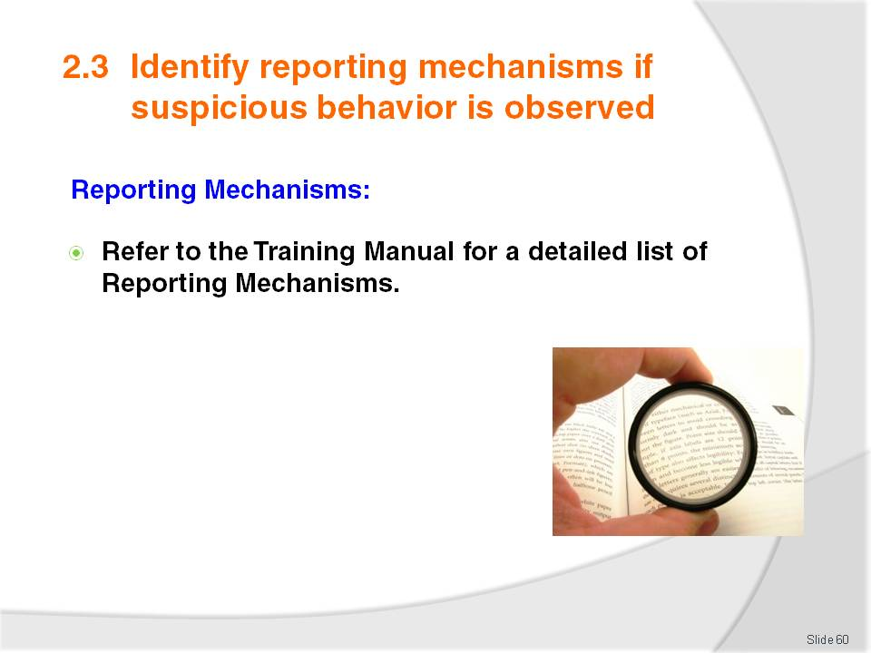
Slide No | Trainer Notes
Trainer to refer class to the Training Manual for a detailed list of Reporting Mechanisms and discuss them with the students.
Activity:
If internet access is available ask the class to research the following:
- Their local Child Helpline International Number
- Their local ECPAT or Child Protection Agency contact details
- The contact details for any local authorities dealing with CST
- The contact details of local embassies.

Slide
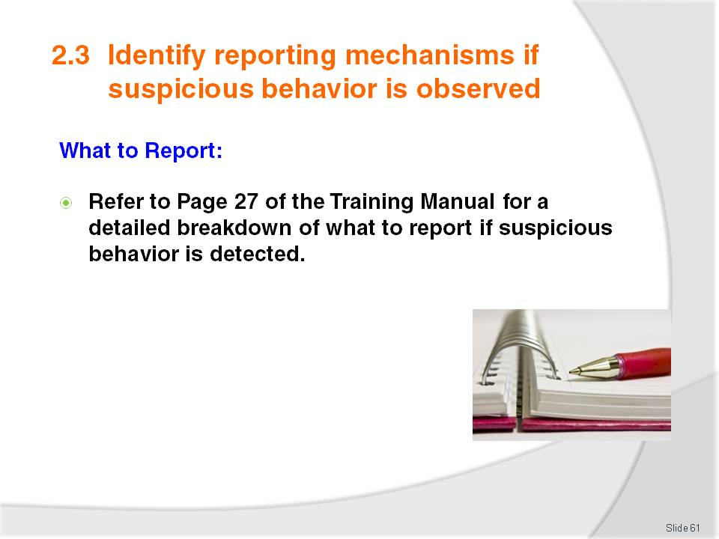
Slide No | Trainer Notes
 | Trainer to refer students to Page 27 of the Training Manual and go through the ‘What to Report’ section.

Slide
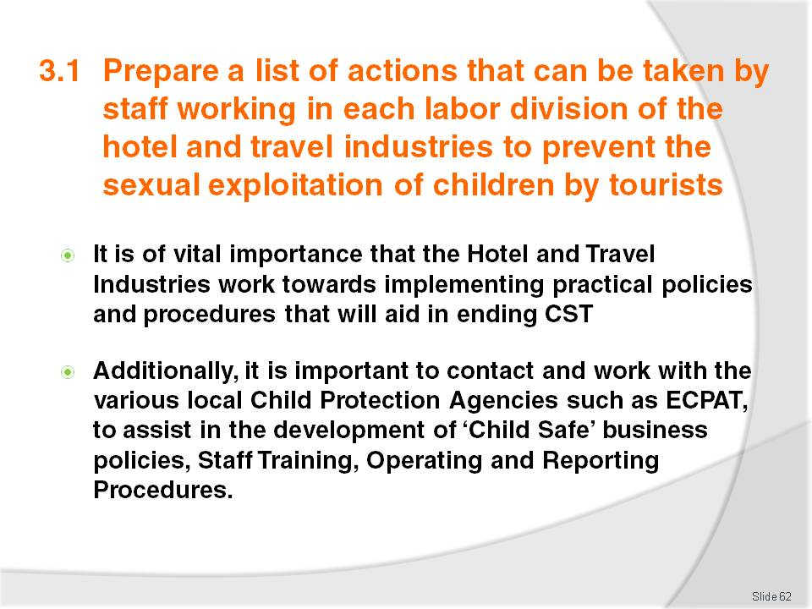
Slide No | Trainer Notes
 | Trainer to discuss the above points.

Slide
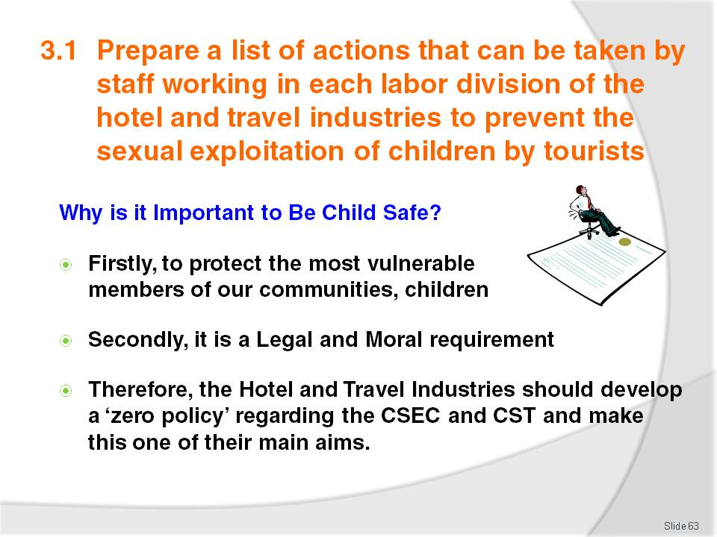
Slide No | Trainer Notes
 | Trainer to discuss the above points.

Slide
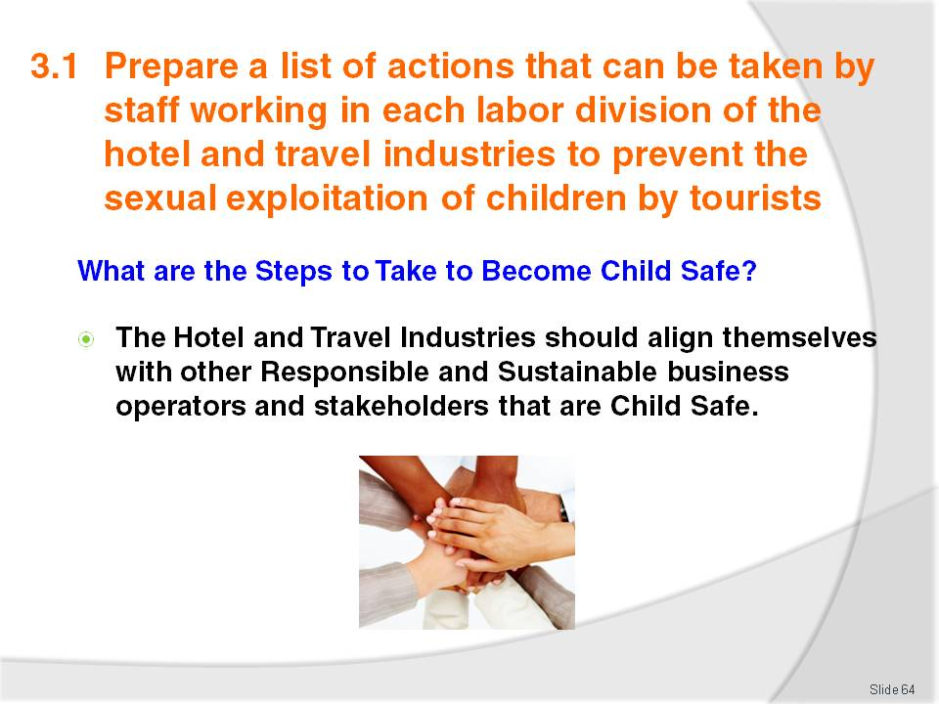
Slide No | Trainer Notes
 | Trainer to discuss the above points.

Slide
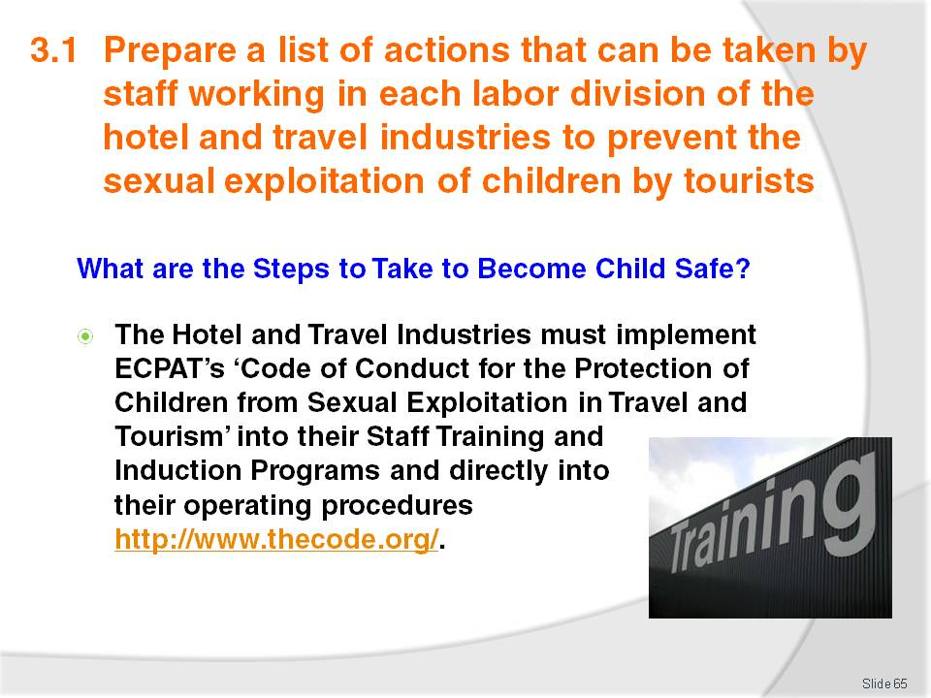
Slide No | Trainer Notes
If you have internet access go to the website (if no internet access download and print copies of the Code of Conduct to give to students):
- http://www.thecode.org/
Take the students through ‘The Code of Conduct for the Protection of Children from Sexual Exploitation in Travel and Tourism’ discussing each dot point and the benefits of adopting this point into the workplace.

Slide
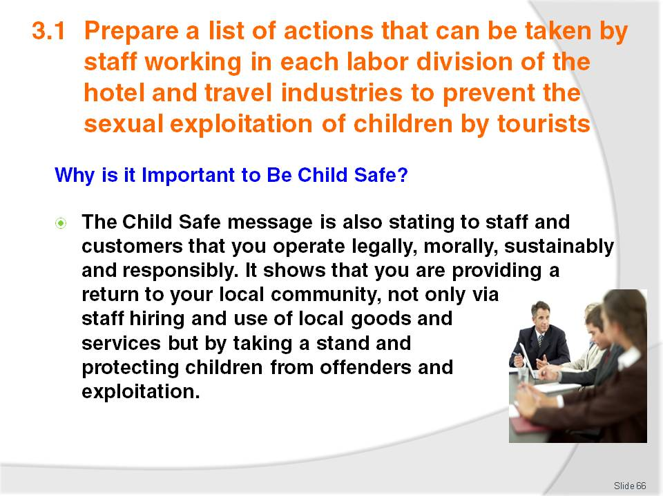
Slide No | Trainer Notes
 | Trainer to discuss the above points.

Slide
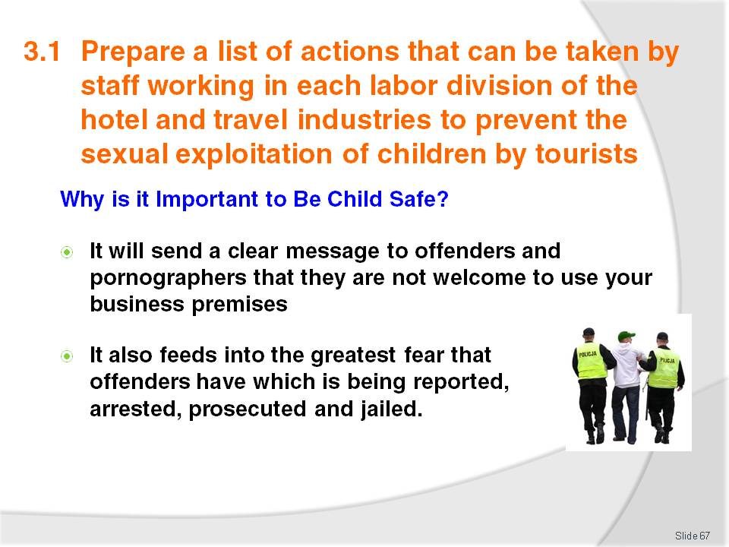
Slide No | Trainer Notes
 | Trainer to discuss the above points.

Slide
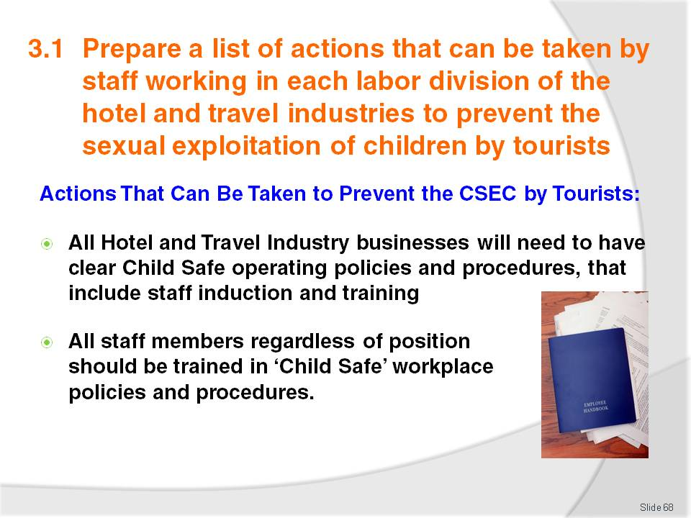
Slide No | Trainer Notes
 | Trainer to discuss the above points.

Slide
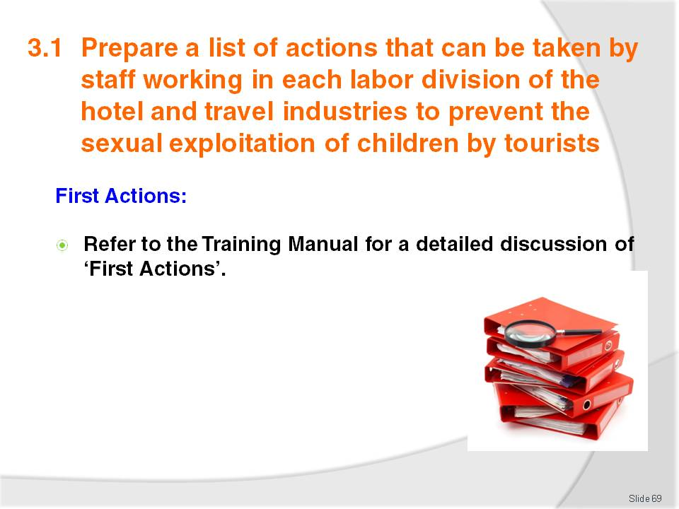
Slide No | Trainer Notes
 | Trainer to refer students to Page 31 of the Training Manual and go through the section ‘First Actions’ asking the class would this be possible in their own workplaces?

Slide
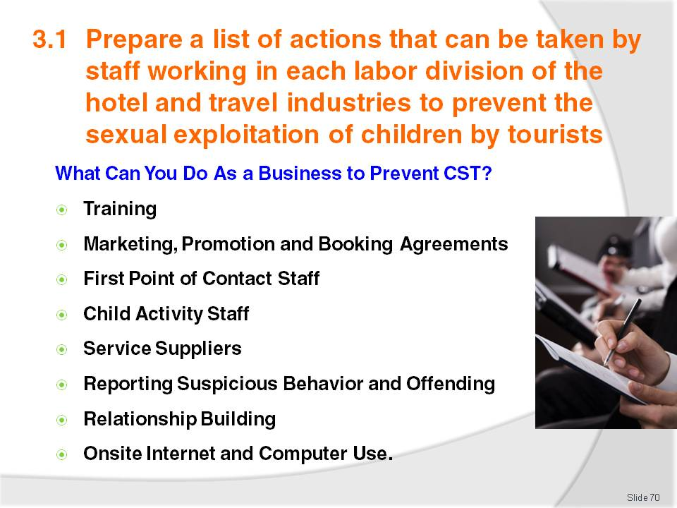
Slide No | Trainer Notes
Trainer to refer the class to the Training Manual for a detailed description of each above point and discuss each point with the class
Activity: Trainer to ask class if each of these points are something that they can do in their own workplaces?

Recommended training equipment
Training materials required consist of:

- Whiteboard
- Computer for Trainer with Internet Access (if possible)
- Student Computers with Internet Access (if possible)
- Projector and Screen
- Printer

Instructions for Trainers for using
PowerPoint – Presenter View
Connect your laptop or computer to your projector equipment as per manufacturers’ instructions.
In PowerPoint, on the Slide Show menu, click Set Up Show.
Under Multiple monitors, select the Show Presenter View check box.
In the Display slide show on list, click the monitor you want the slide show presentation to appear on.
Source: http://office.microsoft.com
Note:
In Presenter View:
You see your notes and have full control of the presentation
Your trainees only see the slide projected on to the screen
More Information
You can obtain more information on how to use PowerPoint from the Microsoft Online Help Centre, available at: http://office.microsoft.com/training/training.aspx?AssetID=RC011298761033
Note Regarding Currency of URLs
Please note that where references have been made to URLs in these training resources trainers will need to verify that the resource or document referred to is still current on the internet. Trainers should endeavour, where possible, to source similar alternative examples of material where it is found that either the website or the document in question is no longer available online.

Appendix – ASEAN acronyms
AADCP | ASEAN – Australia Development Cooperation Program.
ACCSTP | ASEAN Common Competency Standards for Tourism Professionals.
AEC | ASEAN Economic Community.
AMS | ASEAN Member States.
ASEAN | Association of Southeast Asian Nations.
ASEC | ASEAN Secretariat.
ATM | ASEAN Tourism Ministers.
ATPMC | ASEAN Tourism Professionals Monitoring Committee.
ATPRS | ASEAN Tourism Professional Registration System.
ATFTMD | ASEAN Task Force on Tourism Manpower Development.
CATC | Common ASEAN Tourism Curriculum.
MRA | Mutual Recognition Arrangement.
MTCO | Mekong Tourism Coordinating office.
NTO | National Tourism Organisation.
NTPB | National Tourism Professional Board.
RQFSRS | Regional Qualifications Framework and Skills Recognition System.
TPCB | Tourism Professional Certification Board.







